Developing Neural Network Models to Predict Trends in Dublin's Rental Property Market

Nayane Oliveira Araujo

A Thesis Submitted in Partial Fulfilment

of the requirements for the

Degree of

Master of Science in Data Analytics



September 2024

Supervisor: Kislay Raj

# Abstract:

This research aims to analyze the fluctuations in the rental market in the city of Dublin, considering seasonality and supply variations over time, making it difficult for policymakers, agents, and property owners to set fair and appropriate prices. To address these challenges, a housing market study from 2008 to 2023 was conducted using machine learning algorithms, focusing on Neural Networks, to predict rental prices based on specific property characteristics such as location, number of bedrooms, and bathrooms. Model development involved rigorous data preparation steps, statistical testing, and feature engineering to ensure that Neural Networks received quality data for accurate prediction.

The research followed the CRISP-DM methodology, encompassing problem understanding, data collection and cleaning, information enrichment, statistical analysis, model building and evaluation, and prediction and deployment. Models such as RNN, LSTM, and a combination of both were compared, with hyperparameter tuning to select the best-performing model. Public reports were used as primary research sources to understand the business, and a second source of public data was used to perform tests and technical validation. The correlation between variables was verified, and different regression models were tested. Based on the best model identified, rental price forecasts for the next 2 and 4 years were made. The limitations found and the next steps for advancing the research are also discussed in the conclusion.

# Acknowledgements:

I would like to express my deepest gratitude to my supervisor, Kislay Raj, for his invaluable guidance and support throughout this research. I am also grateful to the lecturers and staff at CCT College Dublin, whose expertise and encouragement were essential in the development of this project. My heartfelt thanks to my classmates for their collaboration and to my family, especially my husband, for their unwavering support and motivation during this journey. Finally, I extend my appreciation to all my friends who have been with me throughout this academic endeavor.

# 

Abstract: ii

Acknowledgements: ii

1. Introduction 8

2. Research Details 8

2.1. Research objectives 8

2.2. Research Challenges 8

2.3. Validity 9

2.4. Sampling Strategy 9

2.5. Ethical and Legal/Regulatory Consideration 10

2.5.1. Ethical Considerations in Anonymized Data 10

2.5.2. Approaches to Mitigating Ethical Concerns 10

3. Literature review 11

3.2. Importance of Forecasting Rental Prices in the Property Market 11

3.3. Rental Price Forecast in the Real Estate Market 12

3.3.1. Impact of Rental Price Forecast on the Real Estate Market 12

3.3.2. Limitations of Traditional Forecasting Methods 12

3.3.3. Artificial Neural Networks in Rental Price Forecasting 12

3.3.4. Fundamentals of Artificial Neural Networks 13

4. Primary Research 13

4.1. Introduction 13

4.3. Alignment of the Primary Research with Research Objectives and the Literature Review 14

4.3.1. Alignment with Research Objectives 14

4.3.2. Alignment with the Literature Review 14

4.4. Discussion of Results: Primary Research 15

4.5. Primary research considerations 16

5. Research Methodology 17

5.1. Exploratory Data Analysis 17

5.2. Missing Value Analysis 18

5.3. Imputation of Missing Values 19

5.4. Checking for Infinite Values 19

5.5. Checking for Outliers 20

5.6. Data Visualization 21

5.7. Exploratory Data Analysis of Dublin 25

5.8. Correlation Matrix 26

5.9. Treatment of Outliers in Dublin Data 27

5.10. Statistical Analysis of Stability and Time Dependence in the Rental Market 30

5.10.1. Augmented Dickey-Fuller Test (ADF) 31

5.10.2. Autocorrelation (ACF) and Partial Correlation (PACF) 31

5.10.3. Spearman Correlation 33

5.10.4. Heteroscedasticity Test (Breusch-Pagan) 34

5.11. Conclusion of the Statistical Analysis 34

5.12. Feature Engineering 36

5.13. Feature Engineering and Data Transformation 36

5.13.1. Data Normalization and Structure 36

5.14. Applications of Recurrent Neural Networks (RNN) 36

5.14.1. Recurrent Neural Network (RNN) Model Architecture 36

5.14.2. Visual Analysis of the RNN Model 38

5.15. Hyperparameter Tuning 39

5.15.1. RNN Model with Optimized Hyperparameters 40

5.16. LSTM (Long Short-Term Memory) 42

5.16.1. LSTM Model Architecture 43

5.16.2. Evaluation Results 43

5.16.3. Visual Analysis of the LSTM Model 43

5.16.4. Considerations for the LSTM Model 45

5.17. Combined Model (RNN + LSTM) 45

5.17.1. Architecture of the combined RNN + LSTM model 46

5.17.2. Evaluation Results: RNN + LSTM 46

5.17.3. Visual Analysis of the RNN Model Combined with LSTM 46

5.18. Model Comparison (RNN, LSTM, and RNN + LSTM) 48

5.18.1. Conclusions from the Evaluation Models 50

5.18.2. Points to consider for further improvements 50

5.18.3. Conclusion of the analyzed models 50

5.19. Dublin Forecasts with LSTM + RNN Model and Prediction for 2 and 4 Years 50

5.19.1. Training and Architecture of the Best Model for Short-Term Forecasting 51

5.20. Forecasts for Ireland with LSTM + RNN Model and Prediction for 2 and 4 Years 54

5.20.1. Model Evaluation 54

5.21. Implications for Future Research 56

6. Conclusion 56

7. Analysis and Insights 57

8. Practical Contributions of the Study 58

8.1. Suggestions for Future Studies 58

9. References 58

10. Appendix 60

# 

# 

# 

# 

**Table of Figures**

Figure 1 - Dublin Avg. Price Year/Area 17

Figure 2 - Missing VALUE Distribution by Year 20

Figure 3 - Scatter Plot of Rent Values by Year 22

Figure 4 - Average Rent Value Over the Years 23

Figure 5 - Rent Price Distribution 24

Figure 6 - Average Monthly Rent by Property Type in Ireland 25

Figure 7 - Average Rent Value By Number of Bedrooms 26

Figure 8 - Top 10 Most Expensive Regions in Dublin 27

Figure 9 - Correlation Matrix 28

Figure 10 - Distribution of Rent Values with Outliers 30

Figure 11 - Distribution of Rent Values without Outliers 30

Figure 12 - Boxplot of Rent Prices by Number of Bedrooms in Dublin 31

Figure 13 - Distribution of Rent prices over the years in Dublin 32

Figure 14 - Autocorrelation Function (AFC) 34

Figure 15 - Partial Autocorrelation Function (PACF) 35

Figure 16 - RNN Predictions vs True Values (Original Scale) 40

Figure 17 - Model Loss 41

Figure 18 - RNN Model Loss 43

Figure 19 - RNN Predictions vs True Values (Original Scale) 44

Figure 20 - LSTM Model Loss 46

Figure 21 - LSTM Predictions vs True Values (Original Scale) 47

Figure 22 - RNN + LSTM Model Loss 49

Figure 23 - RNN + LSTM Predictions vs True Values (Original Scale) 50

Figure 24 - Model Loss Comparison (Train vs Validation) 52

Figure 25 - Actual vs Predicted with Error Band 55

Figure 26 - Predicted Value for 2 Years into the Future 56

Figure 27 - Predicted VALUE for 4 Years into the Future 57

Figure 28 - Predicted VALUE for 2 Years into the Future (Improved with Early Stopping) 58

Figure 29 - Predicted Value For 4 Years into the Future (Improved with Early Stopping) 59

**Table of Tables**

Table 1 - Statistics Test 35

Table 2 - Tested Configurations 40

Table 3 - Performance Between Models 49

# Introduction

This study aims to develop and evaluate neural network models, specifically Recurrent Neural Networks (RNN) and Long Short-Term Memory Networks (LSTM), to predict trends in the rental market in Dublin. Using historical rental price data from 2008 to 2023, the research seeks to capture seasonality patterns and variations over time, allowing the elaboration of forecasts for the coming years. By applying machine learning techniques, the study aims to provide a deeper understanding of the dynamics of this market, proposing solutions to the lack of data and offering insights for future housing policies and market strategies.

As a result, the growing demand for housing in Dublin and the limited supply have created major challenges in the city's rental market, resulting in constant price increases over the years. This phenomenon, largely influenced by economic, demographic, and social factors, has made forecasting trends in this market a topic of great relevance for investors, governments, and tenants. Accurate rental price forecasting is essential not only for strategic decision-making but also for ensuring affordability and sustainability in the housing market.

According to information gathered during primary research, the rental market in Dublin has been marked by significant volatility over the past 15 years. Between 2008 and 2023, rental prices increased by an average of 70%, with a sharp recovery after the 2008 economic crisis, followed by accelerated growth after 2014. This research explores the implications of this growth for long-term forecasting, using neural networks to capture trends.

# Research Details

## Research objectives

The main objective of this research is to develop and evaluate neural network models, such as Recurrent Neural Networks (RNN) and Long Short-Term Memory (LSTM) networks, for predicting rental prices in Dublin. Furthermore, this research aims to quantify the impact of missing data on the accuracy of the models and provide recommendations to improve the use of incomplete data in market forecasting.

## Research Challenges

The major challenge of this research is the lack of complete data. About 65% of the data in the dataset is missing, which imposes the need for robust imputation strategies to compensate for the lack of information. This lack of data mainly affects the years 2008 to 2012, when the economic crisis had its greatest impact, which distorts the forecasts by up to 20%. The central issue is to understand to what extent this lack of data compromises the model's ability to accurately predict rental trends, how the market reacts to this uncertainty, and to make the most of the data extracted in the primary research.

## Validity

Validity management, the following components of validity management apply to this project:

**Relevant** – The data used will contain only relevant data to the data analysis project, and sensitive data that may reveal the identity of property owners or postcodes will be used. The relevant resources to this research are identified in the primary research with the analysis of public reports, which gives us the context of the housing market situation, and in the secondary research where the set with sufficient data was acquired for the application of Neural Network models. Only the mandatory data fields are extracted, the analyses performed, as well as the literature review are all relevant to the research topic.

**Reliable** – The data collected is from a reliable source, directly from the Centre Statistics Office of Ireland, the data set was treated according to data exploration standards, so there was no data manipulation to produce distortions, so the primary research was also explored a lot in this study, as both researches meet similar results. All data used in this research as a form of the collection are duly referenced, therefore, the entries obtained are reliable, the literature review carried out in research articles by reliable authors, and its reliability is validated.

## Sampling Strategy

The sampling strategy adopted in this project was developed to ensure data representativeness and maximize the efficiency of the forecasting models. The sampling was done from an extensive dataset, covering average monthly rents in Dublin from 2008 to 2023, provided by the RTB, Average Monthly Rent Report, divided into three types of sampling, temporal sampling, location sampling, and sampling by property characteristics.

* **Temporal Sampling**

Due to the time series nature of rental data, it was essential to sample from specific periods. The data was split into training and testing sets, using the 2008-2019 training period and the 2020-2023 testing period. This split allowed the model to be evaluated in a realistic scenario, considering recent market trends.

* **Location Sampling**

As rental prices can vary significantly between different areas of Dublin, stratified sampling was implemented based on the geographic locations of properties. This ensured that all areas of Dublin were adequately represented, allowing the model to capture regional disparities in rental prices.

* **Feature Sampling**

Relevant variables such as number of bedrooms, property type (house or apartment), and location were selected based on their correlation with rental prices. Sampling took these features into account to ensure the dataset included a wide range of property types and sizes, better reflecting the diversity of the Dublin rental market.

## Ethical and Legal/Regulatory Consideration

The proposed research, titled Developing Neural Network Models to Predict Trends in the Dublin Rental Property Market, uses Big Data to analyze complex patterns and trends in the rental market. The collection and processing of data, even when anonymized, still raises important ethical questions that need to be carefully considered and addressed, according to the Data Protection Act 2018 and GDPR (Data Protection Act, 2018; *General Data Protection Regulation (GDPR) – Legal Text*, 2018). This chapter presents a literature review on the key ethical considerations relating to Big Data research, with a specific focus on the context of the Dublin property market.

### Ethical Considerations in Anonymized Data

While anonymizing data is an important measure to protect individuals’ privacy, it is crucial to recognize that anonymization does not guarantee complete anonymity. Even with anonymized data, there are still risks of re-identification, especially when combined with other sources of information.

In the context of real estate, anonymizing data such as addresses, and zip codes can be challenging. Even if these direct identifiers are removed, other information, such as property characteristics, rental value, and region, can be used to infer an individual's location with reasonable accuracy.

### Approaches to Mitigating Ethical Concerns

To minimize privacy risks and ensure the ethical conduct of research, it is necessary to implement additional measures in addition to anonymization. in addition to anonymization:

* Data aggregation: Analyzing aggregated data by region, rather than individual data, can reduce the risk of re-identification.
* Privacy differential: Mathematical techniques can be used to add noise to data, preserving its usefulness for analysis while protecting the privacy of individuals.
* Data minimization: Collecting only the data strictly necessary for the research, avoiding the collection of excessive or irrelevant information.
* Data governance: Establish a robust data governance plan to ensure responsible and ethical use of collected data. Transparency and communication with stakeholders are crucial to building trust and ensuring that research is seen as a benefit to society.
* Make research results accessible to the public, clearly and understandably. In additional considerations, mention the use of artificial intelligence during the analysis and protection of personal data.
* Ethics of Artificial Intelligence: Research with Big Data often involves the use of artificial intelligence (AI) algorithms. It is important to consider the ethical implications of AI, such as the potential for bias and discrimination.
* Personal Data Protection: Big Data research must comply with personal data protection laws and regulations, such as the European Union General Data Protection Regulation (GDPR).

# Literature review

* 1. Dublin Rental Market Context

Dublin’s property market has been the subject of growing interest due to its dynamic and economic importance in Ireland. In addition, Dublin has emerged as one of Europe’s leading technology hubs, attracting investors and migrants seeking economic opportunities and quality of life(McDermott, 2023). With the city’s continued urbanization and expansion, demand for housing has remained robust (*Residential Property Price Index September 2020 - Central Statistics Office*, 2020). This is particularly evident in the rental market, where supply shortages and rising prices have been frequent topics of debate (Ireland’s housing crisis facts and figures: All you need to know, 2023).

## Importance of Forecasting Rental Prices in the Property Market

Understanding rental price trends in the Dublin property market is crucial for investors, developers, and policymakers. The ability to accurately forecast rental price movements allows for a more efficient allocation of resources that, if used, could contribute to market stability (Annamoradnejad and Annamoradnejad, 2022). In this context, deep learning techniques such as neural networks emerge, which offer new possibilities for analyzing and forecasting trends in the property market (Casolaro *et al.*, 2023).

## Rental Price Forecast in the Real Estate Market

### Impact of Rental Price Forecast on the Real Estate Market

Rental price forecasting in the real estate market, especially when applied to advanced techniques such as machine learning and big data, has demonstrated a significant and transformative impact on the sector. Studies such as that of Grybauskas et al. (2021) highlight the resilience of the real estate market even during periods of economic turmoil, such as the COVID-19 pandemic. This study used 3 different models of Neural Networks to predict price revisions in apartments, concluding that the time-on-market (TOM) variable is particularly influential in predicting price adjustments, indicating that properties listed for longer periods tend to experience price revisions.

### Limitations of Traditional Forecasting Methods

Traditional rental price forecasting methodologies face several limitations, particularly in their ability to process large data sets and adapt to abrupt market changes. As discussed in a paper on traditional forecasting methods, these approaches are limited by their inability to account for seasonality or to adapt quickly to new information, which is crucial for analyses in complex property markets (Traditional Forecasting, 2023). Martin (2019) demonstrates that machine learning methods such as Random Forests and Recurrent Neural Networks outperform traditional methods in dealing with the complexity and volume of data involved in economic forecasting. These techniques were more effective in minimizing errors and accurately capturing data trends when forecasting changes in South Africa’s Gross Domestic Product (Martin, 2019).

### Artificial Neural Networks in Rental Price Forecasting

Artificial neural networks (ANNs) have proven to be a powerful tool for forecasting rental prices in the real estate market, especially due to their ability to model complex non-linear interactions between price-influencing variables. Amrullah (2023) highlights the effectiveness of LSTM (Long Short-Term Memory) ANNs in forecasting rents, leveraging their ability to capture long-term dependencies and extract patterns from historical data. Furthermore, Khrais and Shidwan (2023) note that while conventional methods such as regression can be used for forecasting, they are limited in establishing predetermined relationships between inputs and outputs. On the other hand, ANNs allow for more flexible and adaptive modeling, capable of incorporating a wider range of dynamic and complex factors, essential in the post-pandemic scenario in the Middle East.

### Fundamentals of Artificial Neural Networks

Artificial Neural Networks (ANNs) represent an advanced facet of artificial intelligence, inspired by the complex structure and functionality of the human brain. They are composed of multiple layers of neurons that simulate biological neural activity, processing information through weighted synaptic connections and propagating responses through activation functions, a direct parallel to the functioning of the human brain (Parlak, 2023). At the technical heart of ANNs, layers of neurons use non-linear activation functions, such as ReLU (Rectified Linear Unit), to learn and model complexities inherent in the processed data. This ability to extract and interpret complex non-linear relationships is crucial for applications ranging from image recognition to natural language processing (Ulmann, 2003).

# Primary Research

## Introduction

The primary research for this dissertation focused on the research and analysis of data extracted from annual reports to understand the state of the Irish property market with a focus on the capital city, Dublin. This study was conducted using reports from one of Dublin’s leading real estate platforms, Daft.ie, collecting information from the last sixteen years (Daft Rental Report).

Using the aforementioned data, an in-depth analysis of annual changes in rental prices was conducted to seek to identify significant trends that may influence the local property market and provide a solid basis for further study.

* 1. Primary Research Methodology: Data Collection and Analysis

The research methodology is based on the analysis of data extracted from quarterly rental reports provided by Daft.ie. Reports from the year 2008 to 2024 were used, to provide a comprehensive overview of changes in rental prices in Dublin and compared to other Irish cities as well. The data includes annual and quarterly changes in rental prices, categorized by region.

The data was analyzed and extracted through an extensive reading of historical information on rentals in different regions of Dublin, totaling 16 reports studied in the primary phase.

In conducting the analysis, the following steps were followed:

* **Data Collection:** The data was extracted as mentioned in the lines above, including detailed information on average rental prices in different regions of Dublin and cities outside the capital. This information was systematized in annual spreadsheets to facilitate comparative analysis and the creation of graphs and tables.
* **Price Variation Analysis:** Annual and quarterly variations in rental prices were calculated for each region, with the aim of identifying the areas most affected by price variations during the period. The analysis includes both absolute values ​​and percentages of variation in relation to the historical analysis of the data provided.
* **Visual Representation:** Line and bar graphs were created to highlight the changes in the different regions of Dublin, highlighting the areas most impacted over the period analyzed. In addition, a complementary table was generated that compares rental prices in Dublin with other major cities, such as Cork, Galway, Limerick, and Waterford.

## Alignment of the Primary Research with Research Objectives and the Literature Review

### Alignment with Research Objectives

The primary research objective is to understand the behavior of the rental market in Dublin through historical analysis and to generate insights that will enable subsequent chapters to compare these results with a second dataset. The collection and analysis of data extracted from Daft.ie quarterly reports covering the period 2008 to 2024 serves as a starting point for understanding trends in the Dublin property market.

The study seeks to identify fluctuations in rental prices by region, as discussed in the research objective. The detailed data collection and creation of visual representations, such as line and bar graphs, provide a clear view of price trends, paving the way for future comparisons with another dataset, as foreseen in the research objectives.

### Alignment with the Literature Review

The literature review emphasizes the importance of understanding housing market trends in Dublin, especially in the context of rapid urbanization and growing demand for housing. The primary analysis aligns with these points by providing a detailed and historical analysis of rental prices, as recommended by the literature on the Dublin market. Studies indicate that forecasting price trends is crucial for the efficient allocation of resources by investors, developers, and policymakers, as discussed by Annamoradnejad & Annamoradnejad (2023).

The quantitative and visual approach adopted in the study, by highlighting price variations by region, also reinforces the need for more detailed regional analyses, as suggested by Zhou et al. (2018). In line with the literature, which indicates that different regions within a city like Dublin can exhibit distinct behaviors in response to economic and supply and demand factors.

## Discussion of Results: Primary Research

* **2008 - The Beginning of the Crisis**

In 2008, the Dublin property market was severely impacted by the global financial crisis. Rents fell sharply across all areas of Dublin, with an average fall of 13.1%. Oversupply, caused by falling demand and an increase in available properties, puts downward pressure on prices.

* **2010-2014 - Slow Recovery**

Between 2010 and 2014, the rental market began a gradual recovery, with modest price increases, especially in the City Centre, where demand remained high. However, the outlying areas continued to face economic difficulties, with much slower price increases. 2012 marked the first significant increase in years, with a 4.9% increase in Dublin.

* **2015-2019 - Rapid Expansion**

The period 2015-2019 was characterized by a rapid increase in rents. Demand for housing in Dublin outstripped supply, leading to double-digit rent growth in several areas. 2018 saw an increase of 8.6% in Dublin City Centre and almost 10% in more peripheral areas, and 2019 saw rents continue to rise, albeit at a slightly slower pace compared to previous years.

* **2020 - Impact of the Pandemic**

The COVID-19 pandemic brought an abrupt halt to rent growth in Dublin. For the first time in years, rents fell in 2020 (-5.6% in Dublin City Centre), due to reduced demand and increased supply as short-term rentals moved to long-term contracts.

* **2021-2024 - Post-Pandemic Recovery**

With the return to normality, the rental market in Dublin has resumed its growth, albeit more moderately than in previous years. Between 2021 and 2024, increases were relatively modest, with an annual average of around 2.5% in the City Centre. In 2023, rental growth was 2.4% in Dublin City Centre and 3.8% in West Dublin.

Figure 1 shows the comparison of the average price from 2008 to 2022.

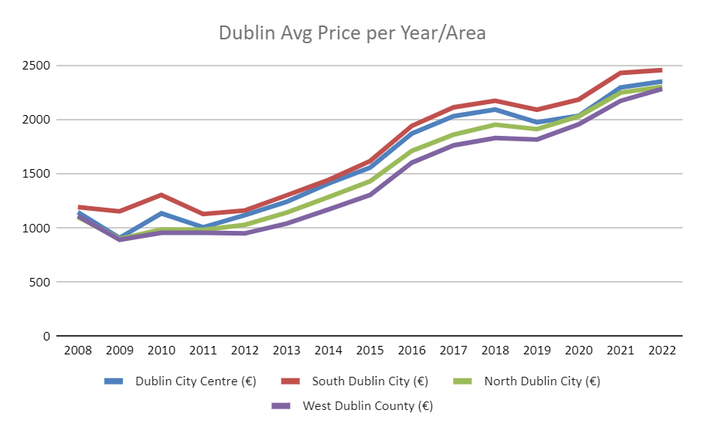

Figure 1 - Dublin Avg. Price Year/Area

## Primary research considerations

The analysis of the Dublin rental market between 2008 and 2024 shows a volatile scenario, impacted by global and local economic factors. Shortages of supply and growth in demand have sustained high rental prices, especially in the City Centre.

Dublin has faced a volatile housing market over the past decades, with periods of rapid increases and sharp falls in rental prices. Between 2008 and 2024, several economic factors, such as the global financial crisis, the COVID-19 pandemic, and the ongoing shortage of housing supply, have shaped the rental market in the Irish capital. This primary research has analyzed rental data from the start of the financial crisis in 2008 to the post-pandemic recovery and growth, with an emphasis on the factors that have affected prices over time. This primary analysis is fully in line with the research objectives and the conclusions of the literature review, providing initial insights that will be essential for future comparisons with a second data analysis, thus generating a complete and robust view of trends in the Dublin property market.

# Research Methodology

The methodology used throughout the process is CRISP-DM, which stands for Cross-Sector Process for Data Mining. The CRISP-DM methodology provides a structured approach to planning a data mining project. It is a robust and proven methodology. (‘Crisp DM methodology’, no date)

Composed of 6 elements, CRISP-DM covers all aspects of a data mining project. Starting with understanding the business, it goes through all the stages and ends with the implementation phase.

When identifying business objectives, the following characteristics of the objectives should be considered: Specific, Measurable, Achievable, Realistic, and Timely.

It is necessary to measure the performance of the strategies to determine whether everything is going well or whether some things need to be changed. (Montenegro, 2019)The Residential Tenancies Board (RTB Average Monthly Rent) dataset, not used in the primary research phase, is crucial for the application of neural network models, due to its robustness and richness of information. The choice of RNN and LSTM models is justified by the temporal nature of real estate market data, which presents complex patterns over time. Such networks are recognized for their ability to capture and memorize these temporal dependencies, which makes them particularly effective tools for predicting price trends based on historical data.

## Exploratory Data Analysis

Exploratory data analysis is a fundamental step in understanding the behavior and structure of data. In the specific case of this study, the goal of EDA is to identify and deal with potential data integrity issues, such as missing values, duplicates, infinite values, and outliers, ensuring that the dataset is ready for predictive modeling with neural networks.

The first part of the code focuses on importing essential libraries for data analysis. The libraries include pandas for data manipulation and analysis, which is the main library used to load and manipulate the dataset, numpy, which was used for numerical operations, such as mathematical and linear algebra functions, matplotlib and seaborn for data visualization. These libraries helped to create graphs and visualizations, which will be useful in exploratory analysis. warnings, the library used to suppress unnecessary warnings that may arise during code execution, was used. This set of libraries is common in data science and machine learning projects, providing the necessary tools for data analysis, visualization, and modeling.

The dataset overview allows us to observe that the dataset used contains the following columns: STATISTIC Label, which describes the statistical data in this case, “RTB Average Monthly Rent Report”, the Year column, the year in which the data was recorded, then Number of Bedrooms, which shows the number of bedrooms of the properties, the Property Type column, which classifies the types of property present in the dataset, the Location column, which indicates the location of the property by area in the dataset, while the UNIT column, which indicates that the unit of the rental value is in Euros, and finally the VALUE column, which shows the average monthly rental value, in Euros, of each property.

A quick check of the data is made, which displays the first five rows of the dataset, allowing an initial visualization of the values. This confirms that the columns are correct and that the data was successfully loaded. This is followed by information about the data type, which displays a more detailed description of the columns, including the data type of each one and the number of non-null values. According to the result of this function, we can observe that the “VALUE” column, which is one of the target variables of this study, has only 104,665 non-null values, suggesting that there are approximately 195,047 missing values. These missing values ​​should be treated in the pre-processing process, through value imputation.

## Missing Value Analysis

As mentioned, the column that stores the rental values ​​has a significant number of missing values, which can negatively influence the model if not treated correctly.

The dataset has 299,712 rows, and 195,047 rows were found with missing values, leaving only 104,665 rows with values, which means that the dataset has a total of approximately 65.1% of missing values. This represents a significant amount of missing data, which could distort the analysis and impair the predictive capacity of the model. As can be seen by viewing the distribution of missing values ​​by year in Figure 2.

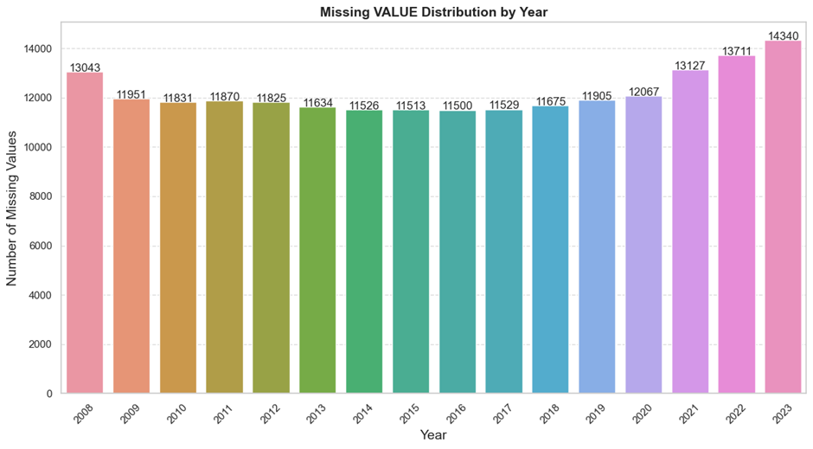

Figure 2 - Missing VALUE Distribution by Year

## Imputation of Missing Values

To deal with these missing values, an imputation strategy was implemented using a progressive three-step approach: imputation by mean based on year and location. The first attempt at filling in the missing values ​​was made by calculating the mean of the rental values ​​for each combination of year and location. This ensures that the imputation maintains the temporal and geographic relationship of the data, preserving possible local or annual patterns. Imputation by annual mean, for cases where there were still missing values ​​after the first step, a new imputation was performed, this time using only the annual mean. This approach seeks to generalize the rental values ​​for a given year, ignoring differences by location. Finally, there was an imputation with the overall median, where, for any missing values ​​remaining after the previous steps, the global median value of the rentals was used, ensuring that all missing values ​​were filled in. These procedures ensured that all missing values ​​were handled appropriately, allowing the full use of the dataset in subsequent stages of the project.

## Checking for Infinite Values

Infinite values ​​can appear in mathematical operations and cause errors during modeling. To ensure data integrity, a function was created to check for the presence of infinite values ​​and temporarily replace them with null values ​​to facilitate counting. After executing this function, it was confirmed that there were no infinite values ​​in the data set.

## Checking for Outliers

Outliers are identified using the IQR (Interquartile Range) method. In this case, the multiplier was set to 3, which allows us to detect extreme points that may be outliers but, as they are high-value properties, can be kept in the dataset. Outliers that are above the upper limit are justified as high-value properties and will be kept in the dataset. Using this approach, 352 outliers were identified, but it was decided that high values ​​above the upper limit would be kept in the dataset, until the filtering stage of the data focused on Dublin, since they represent high-value properties in the real estate market, such as luxury properties in prime areas of Dublin.

Checking for and treating outliers is crucial in the scenario of rental price trends, especially since the real estate market can present a wide variation in property values, depending on factors such as location, size, and condition of the property. Keeping these outliers in the dataset, when justifiable, as in the case of high-value properties, allows the model to more accurately reflect market reality. By avoiding the automatic removal of outliers, ensuring that the model can capture trends and extreme variations, essential for a robust forecast of rental prices, both for common and high-end properties, this is why the multiplier factor is determined as 3, to give us a greater bottleneck in capturing patterns and variance in rental prices over the years analyzed in the learning of logarithms. Below, we can visualize in Figure 3, the distribution of outliers in relation to time (year), using a scatter plot. This visualization helps to understand how rental values, including outliers, have evolved.

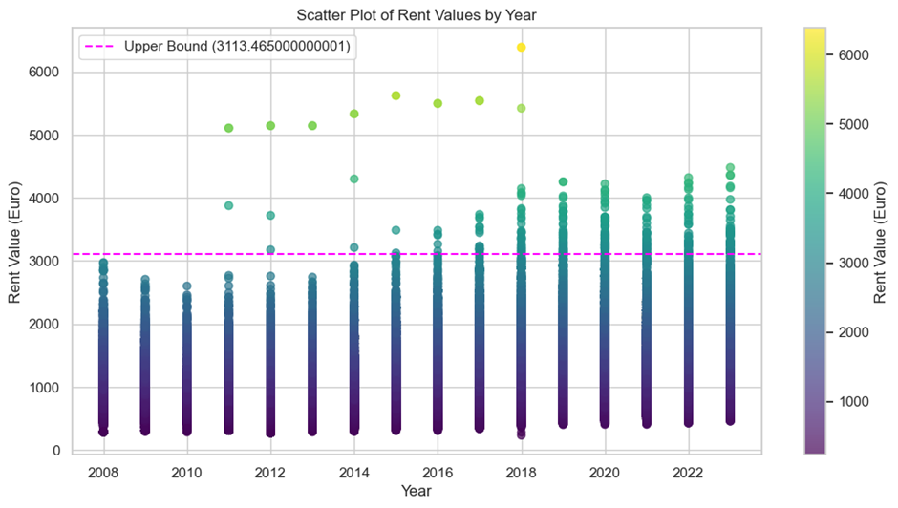

Figure 3 - Scatter Plot of Rent Values by Year

Properly handling missing values ​​and justifying outliers were essential to ensure data quality and integrity, given the various tests performed, thus ruling out the possibility of completely removing missing values ​​and placing a greater limit on flexibility in outlier detection. This visualization allowed us to identify the high-value properties that will be maintained, providing a visual context that reinforces the decision not to remove these data.

## Data Visualization

Data visualization is a crucial step in understanding patterns and trends in data sets, especially when dealing with time series or geographically distributed information, such as in the real estate market. For this study, graphs are used to explore how rental values ​​have evolved over time, the differences between regions and properties, and how these factors may be interrelated. An important principle proposed by Edward Tufte is to maximize the “data-ink ratio”, which advocates the efficient use of graphic elements, eliminating any elements that do not carry relevant information. This ensures that the viewer’s attention is focused on the data itself and facilitates the identification of visual patterns that are truly meaningful (Tufte, 1983).

The first visualization created, Figure 4, to explore temporal trends in rental data is a line chart showing the evolution of average rental value over the years.

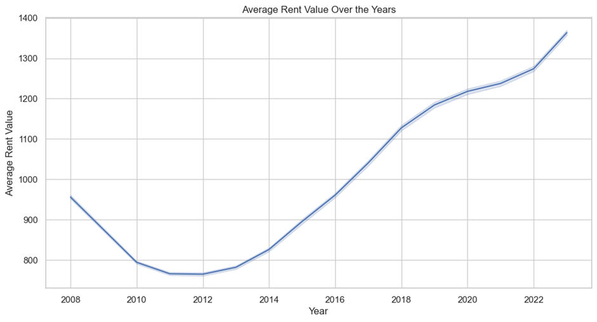

Figure 4 - Average Rent Value Over the Years

The line graph is an appropriate choice because the Year variable is a time series, and the use of a line allows for clear identification of trend patterns. Rising or falling rental values ​​over time can indicate economic cycles, government policies such as rental market regulations, or changes in housing demand in Dublin and other regions of Ireland. The presence of a grid makes it easier to read the values ​​over time, making it easier to compare year-to-year changes.

Histograms were then generated for the main cities on Figure 5, including Dublin, showing the distribution of rental values ​​in each. Comparison between locations is particularly relevant when considering the heterogeneity of the housing market in Dublin and other regions of Ireland.

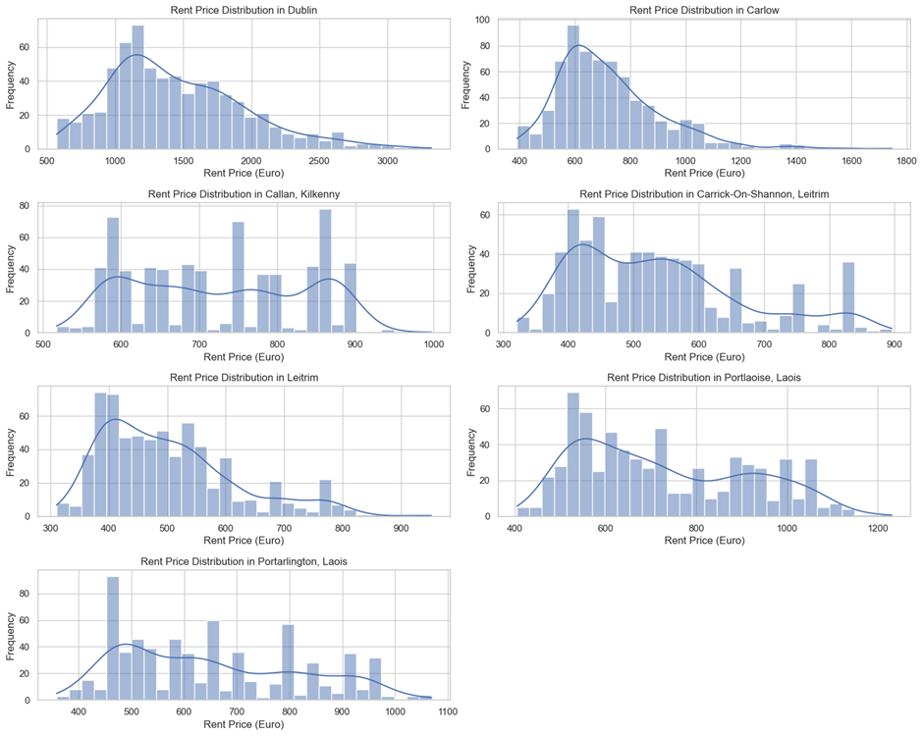

Figure 5 - Rent Price Distribution

In Dublin, the distribution of prices follows an asymmetric trend to the right, with the highest concentration of rentals between €1,200 and €1,500. The long tail reflects the presence of high-value properties, common in large metropolitan centers due to high demand and limited supply.

In Carlow, the asymmetry is also present, but with lower prices, between €600 and €800, and a few properties above €1,000, characterizing a more affordable region. In Callan, Kilkenny, the distribution is more irregular, with peaks in different price ranges, suggesting variability in the available properties.

Carrick-On-Shannon in Leitrim, and Leitrim as a whole, follow a pattern of prices between €400 and €700, with a long tail reflecting higher-value properties but fewer in number. Price variability in Portlaoise and Portarlington, both in Laois, is more dispersed, with price ranges between €600 and €1,200, indicating a mix of properties, including some higher-value properties.

Overall, the graphs suggest that urban areas, such as Dublin, have a more concentrated and predictable distribution of rents, while smaller or rural areas show greater variability. The presence of long tails in several regions suggests that there are premium properties in markets with lower average prices. This variability reflects the disparity in the rental housing market in Ireland, with Dublin standing out as the most expensive and diverse market, and areas such as Leitrim and Carlow having significantly lower prices. These charts are essential for visualizing market trends and understanding how rental prices vary across regions, which is crucial for accurately modeling price trends and predicting future market behavior.

Another important chart is the comparison of average rental prices by property type, visualized through a horizontal bar chart, Figure 6.

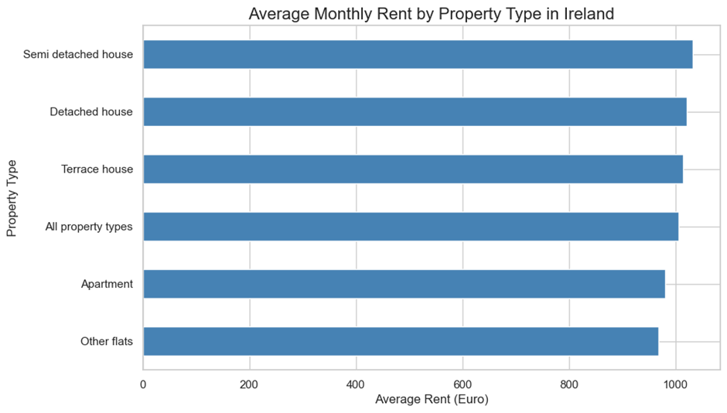

Figure 6 - Average Monthly Rent by Property Type in Ireland

The bar chart is ideal for comparing discrete categories, such as different property types such as apartments, houses, and townhouses.

The visualization provides insights into the average price of each property type, allowing you to identify which types of properties are more expensive or more affordable in terms of rent. Rental behavior across different property types reflects tenant preferences, the size and standard of the dwellings, and the demographics of those renting those properties.

Finally, a bar chart displays the average rental price by number of bedrooms, Figure 7.

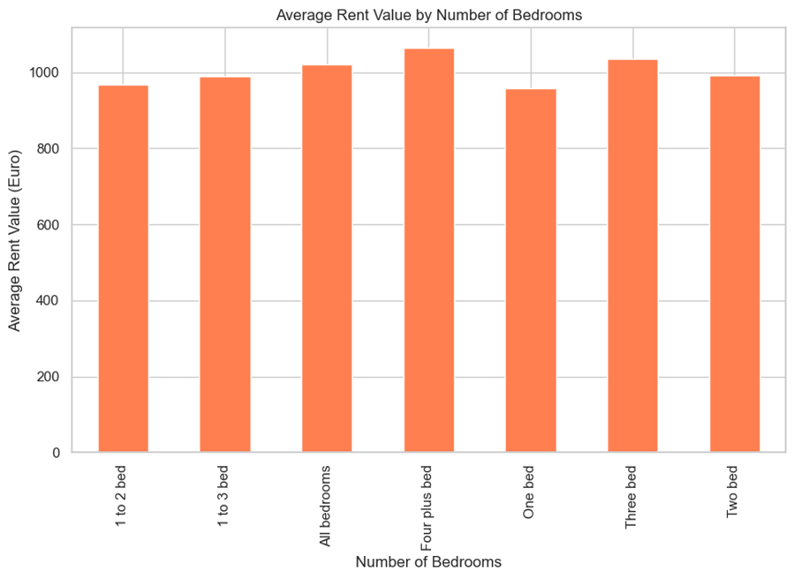

Figure 7 - Average Rent Value By Number of Bedrooms

The number of bedrooms is a critical variable in the real estate market, as it is directly related to the size and capacity of the property, directly influencing the rental price. The vertical bar chart clearly shows how the number of bedrooms affects the average rental price, with properties with more bedrooms tending to be substantially more expensive. This visualization can also reveal non-linear price discrepancies, where an increase in the number of bedrooms may not correspond to a proportional increase in price, depending on the region.

The visualizations described play a crucial role in understanding the data in depth and provide valuable insights into the temporal trends in the rental market, regional differences, and specific property characteristics that influence prices. Using appropriate visualization techniques allows you to detect latent patterns, regional discrepancies, and market trends, making the results easier to interpret and helping to guide the next steps of predictive analysis with neural networks.

## Exploratory Data Analysis of Dublin

The first step in this phase was to filter the entries in the Location column that contain the term "Dublin", thus creating a specific subset of data for further analysis. Dublin is a key and differentiated region in the Irish real estate market, which justifies this focus.

The function used for this filtering is capable of identifying all occurrences of "Dublin", regardless of the upper or lower case. After the filtering process, the data is stored in a new CSV file for future analysis. After filtering, the average rental value for each location within Dublin was calculated. The objective here is to identify the regions with the highest average rental cost, providing an overview of the most expensive areas of the city. Based on the average rentals obtained, the 10 most expensive regions were selected for visualization in a bar chart as shown on Figure 8.

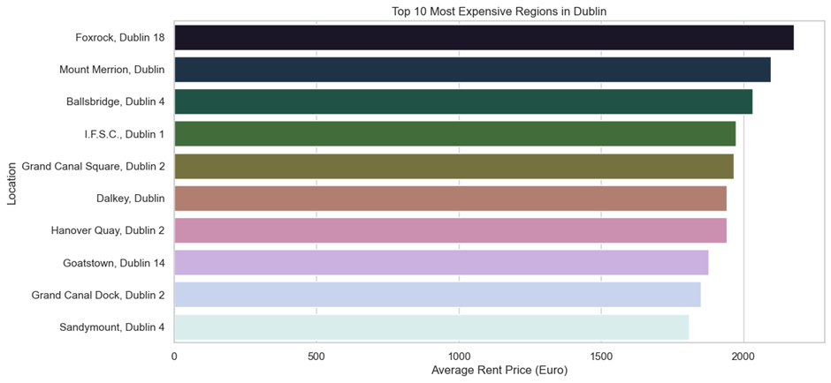

Figure 8 - Top 10 Most Expensive Regions in Dublin

An analysis of the figure, which presents the “Top 10 Most Expensive Regions in Dublin”, reveals important insights into the distribution of rental prices in the most expensive areas of the city. The regions with the most expensive rents are spread across the central and suburban areas, but they all share a common characteristic: they are considered to be prestigious areas in Dublin. The concentration of high-rent areas in Dublin 2 and Dublin 4 suggests that proximity to the Financial and Business Centre, as well as the quality of infrastructure, significantly influences rental prices.

This graph will be very useful to contextualize the analysis of the data in the rental price forecast modeling, as it reflects areas with greater volatility and potential for growth in terms of demand.

The bar chart clearly reveals the premium regions of Dublin, where rents are highest. These areas are likely to include commercial districts, such as Dublin 1 (City Centre), and luxury residential areas such as Blackrock and Booterstown. These areas are associated with proximity to economic centers, universities, and access to transportation infrastructure, factors that typically drive up rental prices.

## Correlation Matrix

The correlation matrix was generated to understand the relationships between the numerical variables within the Dublin subset, selecting only the column referring to the year and the value of the property prices. The number of bathroom variables was removed because much of the data in this column was classified as “all bedrooms”, making it difficult to impute values ​​using averages. Several tests were performed before discarding this variable, analyzing the value of the correlation obtained with the inclusion of this variable, Figure 9.

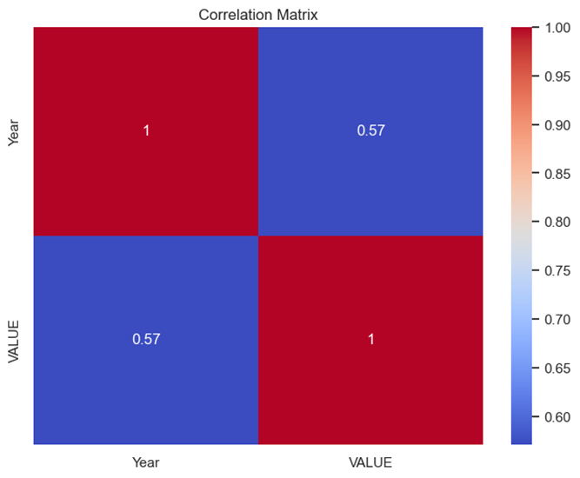

Figure 9 - Correlation Matrix

The correlation matrix shows the linear relationship between two variables, year and value. The diagonals indicate a perfect correlation of 1, which is expected since each variable is perfectly correlated with itself. The off-diagonal values ​​represent the correlation between year and value, which is 0.57. This correlation suggests a moderate positive relationship between the two variables. This means that as the years progress, the value tends to increase. However, this is not a perfect or very strong correlation, since the value is well below 1.

The relationship is significant enough to indicate that the value generally increases over time, but there are probably other factors besides time that influence the changes in values.

## Treatment of Outliers in Dublin Data

Outliers were previously identified and treated using the adjusted IQR method. Here, the focus was on retaining the high-value outliers that may represent properties with values ​​well above the norm, while removing only those that are considered undesirable.

The adjusted IQR method uses a multiplier of 3 to identify ‘outliers’ based on the interquartile distribution of rental values. This allows for the removal of anomalous values ​​that are well above or below the expected range while retaining the high-value outliers that are an important part of the luxury market in Dublin. After the adjustment, 218 outliers were detected, and the dataset was updated and saved to ensure the data was ready for further analysis.

Two visualizations were created to compare the distribution of rental values ​​with and without outliers, using histograms with KDE (Kernel Density Estimation) to highlight the central trends in the data.

* Chart with the presence of outliers, in Figure 10.

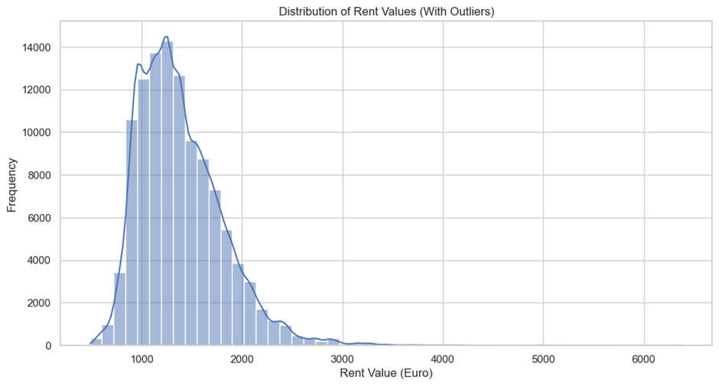

Figure 10 - Distribution of Rent Values with Outliers

The visualization with outliers shows a distribution of prices with a long tail on the right, reflecting the presence of properties with much higher values. This is typical in real estate markets where there is a large disparity in values ​​between more affordable and high-end properties.

* Without outliers, values ​​below the upper limit, in Figure 11.

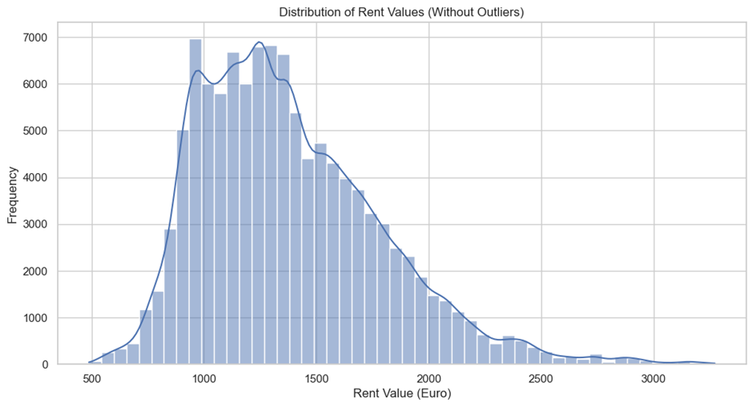

Figure 11 - Distribution of Rent Values without Outliers

By removing the outliers, the distribution becomes more symmetrical, focusing on the most common price ranges for the Dublin rental market, making it easier to analyse general trends without the disproportionate influence of extremely high prices. Boxplots were used to explore the distribution of rental prices in relation to number of bedrooms and year:

* Outliers of the number of bedrooms in relation to the rental price, Figure 12:

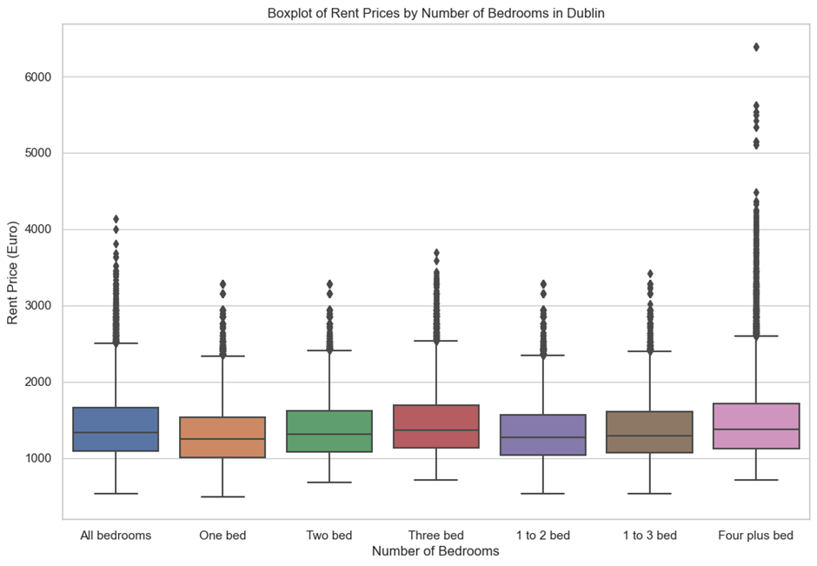

Figure 12 - Boxplot of Rent Prices by Number of Bedrooms in Dublin

The boxplot of the number of bedrooms confirms that properties with more bedrooms tend to have a higher price dispersion. In addition, properties with four or more bedrooms have significantly higher rental values, often with outliers that reflect high-end properties.

* Outliers detected in rental values ​​by year, in the Figure 13:

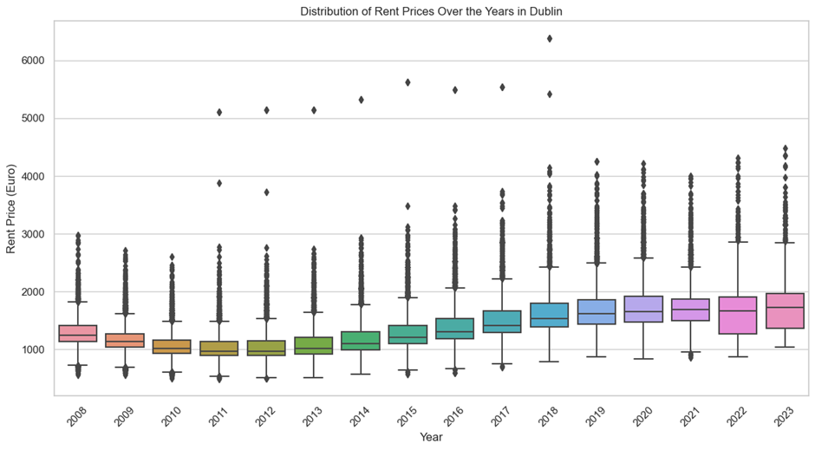

Figure 13 - Distribution of Rent prices over the years in Dublin

The boxplot of rental values ​​by year highlights the trend of rising rental prices over time, with more pronounced outliers in recent years, indicating that high demand for housing in Dublin is driving prices up.

The most expensive areas are arguably concentrated in premium areas of the city, many of which are close to the financial and commercial hubs. The outlier analysis showed that while there are some very high-value properties, these should be retained in the dataset to reflect the diversity of the capital’s housing market.

This information is crucial for feeding into the predictive models that will be developed in later stages, allowing neural networks to capture the regional and temporal nuances of the Dublin rental market.

## Statistical Analysis of Stability and Time Dependence in the Rental Market

In this section, a series of more detailed statistical analyses were performed to verify the stability and time dependence of the Dublin rental market. The purpose of using these statistical tests was to assess whether the time series of rental values ​​in the city of Dublin presents characteristics such as stationarity, autocorrelation and heteroscedasticity, which are essential for the construction of robust predictive models, aimed at creating tests for neural network applications.

### Augmented Dickey-Fuller Test (ADF)

“The Augmented Dickey-Fuller Test (ADF) was used to verify whether the time series is stationary or not. This test is applied in time series analysis, especially when one wants to model forecasts based on past data, since a stationary series is one whose statistical properties, such as mean and variance, do not change over time.” Enders, W. (2004)

* The p-value of 1.02e-16 is much smaller than 0.05, which means that we can reject the null hypothesis. In the ADF (Augmented Dickey-Fuller) test, the null hypothesis is that the series is not stationary. By rejecting this null hypothesis, we are accepting the alternative hypothesis that the series is stationary.
* The ADF statistic of -9.709 is smaller than all the critical values ​​(-3.43, -2.86, -2.57), which reinforces the rejection of the null hypothesis. The more negative the ADF statistic is compared to the critical values, the stronger the evidence that the series is stationary.

### Autocorrelation (ACF) and Partial Correlation (PACF)

The Autocorrelation Function (ACF) and the Partial Autocorrelation Function (PACF) are fundamental tools in the analysis of time series, especially in the identification of temporal dependence patterns. The ACF measures the correlation between the values ​​of a time series at different lags, that is, in past time intervals. The PACF measures the correlation between the values ​​of the series at specific lags, adjusting for the intermediate values ​​between these lags (Brownlee, 2024).

The ACF is mainly used to identify the general behavior of the series over time, while the PACF helps to identify the order of an autoregressive model, removing indirect correlations caused by previous lags. This type of analysis is useful, for example, in the specification of models for forecasting time series (Frost, 2024).

The next step in time series analysis is to check the autocorrelation of the data, that is, how the rental values ​​relate to their past values ​​by measuring the correlation between a value and its lagged values, adjusting for the intermediate values, as shown in figures 14, and 15.

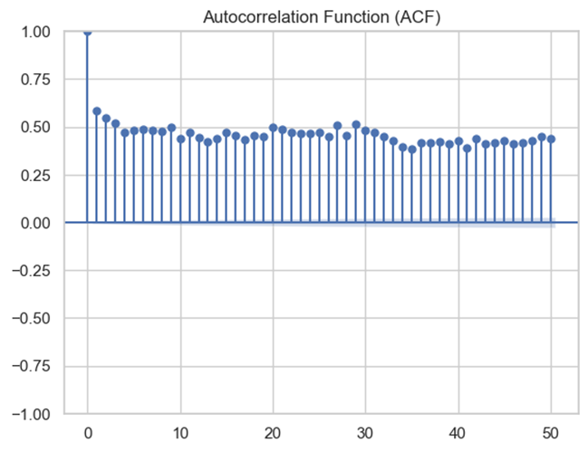

Figure 14 - Autocorrelation Function (AFC)

The ACF graph shows the dependence of rental values ​​over time. Significant spikes indicate that values ​​are correlated with previous values ​​at certain time lags.

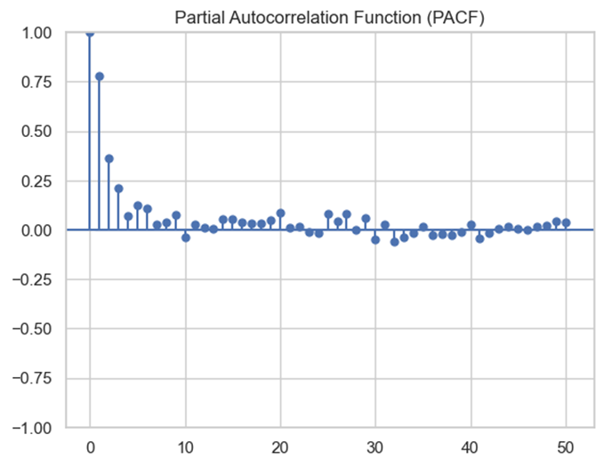

Figure 15 - Partial Autocorrelation Function (PACF)

The PACF chart adjusts for this dependence to remove intermediate correlations, helping to identify how many lags need to be included in predictive model-building approaches. The presence of significant autocorrelation in the early lags suggests that there is a strong temporal dependence in the rental data.

### Spearman Correlation

Spearman Correlation is a nonparametric measure that assesses the strength and direction of the monotonic association between two variables. In this case, the correlation between the year (time) and the rental value is analyzed to identify whether there is a predictable relationship between these variables over time. This correlation is useful when the variables do not follow a normal distribution or have an ordinal relationship, being an alternative to Pearson correlation for nonlinear or non-normally distributed data (Frost, 2024).

* Spearman's correlation test obtained a correlation value of 0.621, indicating a moderate positive correlation between the year and rental values. In other words, as time passes, there is a tendency for rental prices to increase. While the p-value is 0.0, indicating that this correlation is statistically significant and rental prices tend to increase over time, which suggests an upward trend in the Dublin property market.

### Heteroscedasticity Test (Breusch-Pagan)

Heteroscedasticity occurs when the variance of the errors in a regression model is not constant over time, which can complicate predictive modeling. The Breusch-Pagan Test is used to verify the presence of heteroscedasticity in regression models. This test is based on the null hypothesis that there is homoscedasticity, that is, the residuals have constant variance. If the p-value obtained is less than the significance level, the null hypothesis is rejected, indicating the presence of heteroscedasticity (Breusch & Pagan, 1979).

* The Breusch-Pagan Test Statistics found a value of 614.33, indicating the presence of heteroscedasticity. The p-value is 1.28e-135, which suggests that heteroscedasticity is highly significant, and the variance of rental values ​​is not constant over time, indicating heteroscedasticity. This suggests that the volatility of the rental market in Dublin may vary over the years, which should be considered in future predictive models.
  + 1. Normality Test (Shapiro-Wilk)

The Shapiro-Wilk test is used to assess whether data follow a normal distribution. This test verifies the null hypothesis that the sample was taken from a population with a normal distribution. If the p-value is less than the significance level (usually 0.05), we reject the null hypothesis, indicating that the data do not follow a normal distribution (Shapiro & Wilk, 1965).

If the data does not follow a normal distribution, transformations such as the logarithmic transformation or square root can be considered to improve model performance. In addition, normality can affect how the data is scaled, a crucial step in many neural networks to ensure that weights and gradients are adjusted appropriately during training (Shapiro & Wilk, 1965).

* The Shapiro-Wilk Statistic test obtained a value of 0.938, indicating that rental data in Dublin does not follow a normal distribution. The p-value is 0.0, which rejects the null hypothesis of normality, showing that rental values ​​are not normally distributed, which can be explained by the presence of outliers, previously explained the decision to keep their presence up to a certain limit, and a possible asymmetry in the distribution.

## Conclusion of the Statistical Analysis

The statistical analysis of the rental data in Dublin revealed a series of important characteristics for the time series modeling phase, such as stationarity indicated by the Dickey-Fuller Test; temporal dependence, where the series presents significant autocorrelation, especially in the first lags, suggesting a strong temporal dependence; the upward trend, as in the Spearman correlation, confirmed that rental values ​​increase over time, reflecting an upward trend in the market; the heteroscedasticity test tells us that the rental market presents heteroscedasticity, indicating that price volatility varies over time; and finally the normality test, where the rental value data does not follow a normal distribution, which may require the use of techniques that are robust to outliers and asymmetric distributions. All these characteristics should be considered when choosing predictive models, RNN and LSTM, which can deal with temporal dependence, heteroscedasticity, and non-normal distributions more effectively, view Table 1.

|  |  |  |  |  |
| --- | --- | --- | --- | --- |
| **Test** | **Statistic Value** | **Critical Values** | **p-value** | **Interpretation** |
| Augmented Dickey-Fuller Test (ADF) | -9.709 | -3.43, -2.86, -2.57 | 1.02e-16 | Stationary series (reject null hypothesis) |
| Autocorrelation (ACF) | N/A | N/A | N/A | Identifies temporal dependencies |
| Partial Autocorrelation (PACF) | N/A | N/A | N/A | Removes intermediate correlations |
| Spearman Correlation | 0.621 | N/A | 0.0 | Moderate positive correlation between year and rental value |
| Heteroscedasticity Test (Breusch-Pagan) | 614.33 | N/A | 1.28e-135 | Heteroscedasticity present |
| Normality Test (Shapiro-Wilk) | 0.938 | N/A | 0.0 | Data does not follow normal distribution |

Table 1 - Statistics Test

## Feature Engineering

In this section, we explore the development and evaluation of three different models, a Recurrent Neural Network (RNN), a Long Short-Term Memory (LSTM), and finally a combined RNN and LSTM model. These models are applied to rental data to predict future values ​​using temporal features and other auxiliary variables. The detailed analysis involves data preparation, model training, evaluation of predictions, and comparison between the results obtained with each architecture.

## Feature Engineering and Data Transformation

The main steps and techniques applied are the creation of temporal features and the use of year and month as features to capture seasonal variations and long-term trends. The original dataset was expanded by including temporal variables such as year, month (with one-hot encoding), and percentage changes in rental prices in different lag periods. This ensures that the model captures temporal dynamics in a robust way. The target log variable was transformed to stabilize the variance, in addition, percentage changes were created to capture variations in short periods, which can improve the predictive capacity of the model especially to deal with heteroskedasticity, as identified in the Breusch-Pagan Test.

### Data Normalization and Structure

The data was normalized using MinMaxScaler, a crucial step for neural networks as it ensures that the values ​​are on a scale compatible with efficient optimization, and the dataset was split into 80% for training and 20% for testing.

The data was then restructured into the format required for the RNN and LSTM models, with the form samples, time step, and features.

## Applications of Recurrent Neural Networks (RNN)

### Recurrent Neural Network (RNN) Model Architecture

The model was configured with a Simple RNN layer with 100 units, followed by a Dropout layer to avoid overfitting and a Dense layer to generate the prediction of an output value. The model was trained for 50 epochs, using 80% of the data for training and 20% for validation. During the training process, both the training loss and the validation loss were monitored to ensure that the model was learning without overfitting, with the implementation of Early Stopping to stop training if the validation loss stopped improving. The model performance was evaluated with the Root Mean Squared Error (RMSE) and Mean Absolute Error (MAE), which measure the accuracy of the predictions, and the model achieved the following results on the test set.

In the first few epochs, the model showed a rapid decrease in the loss function on the validation set, which was 0.0666, and in the second epoch, there was a significant reduction to 0.0543. This behavior is common because, in the first few iterations, the model makes larger adjustments to the connection weights, which usually results in a rapid improvement in the loss function. From epoch 6 onwards, the rate of loss reduction became more stable. The loss on the training and validation sets began to decrease more slowly, suggesting that the model was gradually adjusting the weights to capture patterns in the data. In epoch 10, for example, the validation loss was 0.0313, while the training loss was 0.0327, and this behavior reflects a common transition in neural network training.

The difference between the training loss and validation loss curves is a crucial indicator of the model’s ability to generalize, and throughout the training process, the difference between these two metrics was minimal, suggesting that the model is not overfitting to the training data.

At epoch 50, the validation loss was 0.0239, compared to a training loss of 0.0243. The closeness of these values ​​indicates that the model is generalizing well, without suffering from overfitting.

After training was complete, the final evaluation on the test set resulted in a loss of 0.0239, which is consistent with the loss observed on the validation set during the last few epochs. This relatively low value for a squared error metric suggests that the model is a good fit to the data. Furthermore, the consistency between the training and validation metrics across epochs and the final test loss indicate that the model has good generalization ability to new data.

Over the 50 training epochs, the model showed a continuous improvement in loss on both the training and validation sets. The loss on the training set decreased from 0.1143 in the first epoch to 0.0243 in the last, while the loss on the validation set decreased from 0.0666 to 0.0239. This suggests that the model is learning effectively, with no obvious signs of overfitting, as the training and validation losses converge smoothly and in a controlled manner, with no major disparities between them.

It can be concluded that the Recurrent Neural Network (RNN) model performed well in predicting rental values, as indicated by the RMSE (0.2131) and MAE (0.1726) values. The Dropout regularization strategy and the use of Early Stopping helped to avoid overfitting, resulting in a model that generalizes well to new data.

### Visual Analysis of the RNN Model

The plot of predictions versus actual values ​​in Figure 16 shows that the model was able to closely track actual rental values, demonstrating its effectiveness in capturing temporal patterns. The steady reduction in loss during training suggests that the model is well-tuned.

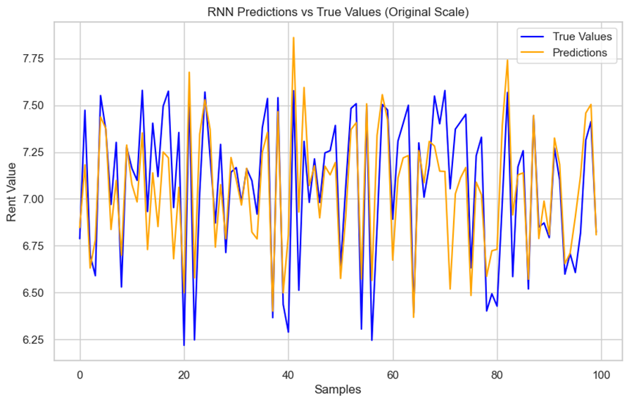

Figure 16 - RNN Predictions vs True Values (Original Scale)

* Loss Over Epochs

The training history was plotted to show the evolution of the loss over epochs, both the training and validation losses decreased consistently, indicating that the model is learning and generalizing effectively, see Figure 17.

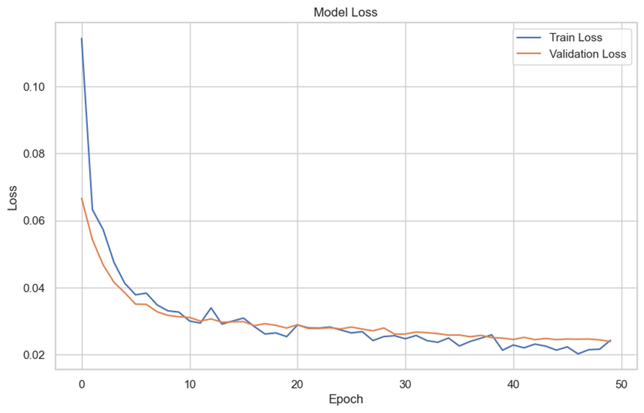

Figure 17 - Model Loss

## Hyperparameter Tuning

Hyperparameter tuning was used to optimize the performance of the models. Four main hyperparameters were tuned: the number of units in the RNN layer, the dropout rate, the batch size, and the learning rate. The performance metrics used were the Root Mean Squared Error (RMSE) and the Mean Absolute Error (MAE), calculated based on the predictions made on the test set. The tuning process involved varying the number of units (neurons) in the RNN layer, using 50, 100, 150. The Dropout Rate was 0.2, 0.3, 0.4, the batch size was 16, 32, 64, and the learning rate was 0.001, 0.005, 0.01.

The tuning was performed using a grid search approach, where all combinations of hyperparameters were tested.

The results showed significant variations in model performance with different hyperparameter combinations, looking at units in the RNN layer, increasing the number of units to 100 and 150 generally resulted in better performance compared to 50 units, although results varied with the other hyperparameters.

Regarding Dropout, dropout rates of 0.2 and 0.3 tended to produce better RMSE and MAE results. Dropouts of 0.4 generally increased errors, possibly due to excessive reduction in the network's learning capacity. A smaller batch size, such as 16 or 32, generally led to better model fit compared to a batch size of 64, which consistently showed higher RMSE and MAE values. A learning rate of 0.001 proved efficient for many combinations, but higher rates, such as 0.005 and 0.01, showed improvements in some cases.

Highlighting some of the best-tested configurations, which resulted in the lowest RMSE and MAE values, in Table 2.

|  |  |  |  |  |  |  |
| --- | --- | --- | --- | --- | --- | --- |
| **Configuration** | **Units** | **Dropout** | **Batch Size** | **Learning Rate** | **RMSE** | **MAE** |
| 1 | 150 | 0,4 | 32 | 0,01 | 0,1929 | 0,1519 |
| 2 | 150 | 0,2 | 16 | 0,005 | 0,1974 | 0,1548 |
| 3 | 100 | 0,3 | 16 | 0,01 | 0,1977 | 0,1617 |

Table 2 - Tested Configurations

**Configuration 1**: This configuration showed the lowest RMSE among all combinations tested. Using 150 units and a dropout rate of 0.4, combined with a learning rate of 0.01 and a batch size of 32, provided the best fit to the dataset.

**Configuration 2:** With a lower dropout rate (0.2) and a small batch size (16), the model also performed very well, with an RMSE of 0.1974.

**Configuration 3:** This combination, with 100 units and a dropout rate of 0.3, also achieved a good result.

### RNN Model with Optimized Hyperparameters

The behavior of the Recurrent Neural Network (RNN) model after hyperparameter tuning was built using the best hyperparameters identified during the hyperparameter tuning process, using 150 units (neurons), Dropout 0.4, batch size 32, and learning rate 0.005. These hyperparameters were selected based on previous experiments that tested several combinations of values.

The model architecture consisted of a SimpleRNN layer with 150 units and ReLU activation, a Dropout regularization layer with rate 0.4 to prevent overfitting, and a dense output layer with a single neuron to predict the logarithmically transformed rent value.

The model was trained for up to 50 epochs, with Early Stopping to monitor validation loss and stop training if there were no improvements after 10 epochs.

The training history showed a continuous reduction in loss across epochs, both in the training and validation sets, indicating good learning of the model, Figure 18.

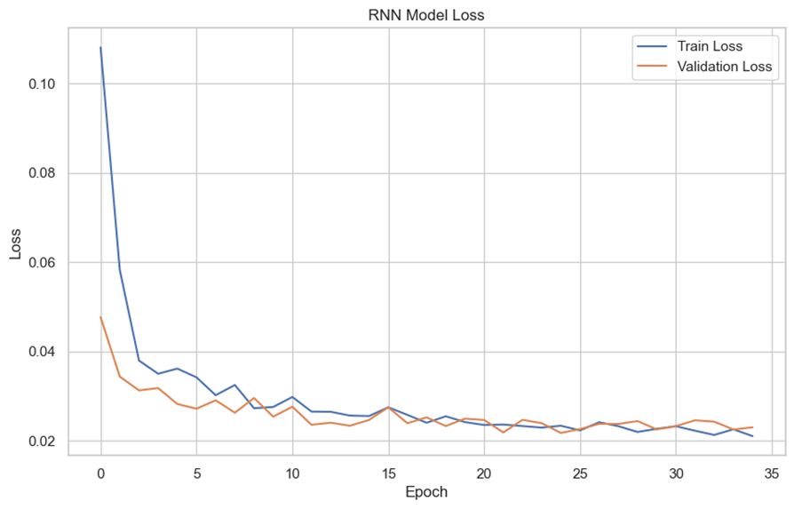

Figure 18 - RNN Model Loss

The loss curve suggests that the model converged efficiently, with a progressive decrease in validation loss throughout training, and early stopping was triggered after approximately 40 epochs when validation loss stopped improving.

After training, the model was evaluated on the test set, obtaining the following results for RMSE (Root Mean Squared Error): 0.2034 and MAE (Mean Absolute Error): 0.1613. These values ​​indicate that the model was able to capture the patterns in the rental data well, with a relatively low error in the predictions.

Figure 19, below compares the actual rental values ​​(adjusted to the original scale) with the model predictions. This visualization shows how well the model can capture the fluctuations in rental values.



Figure 19 - RNN Predictions vs True Values (Original Scale)

The graph shows that the RNN model was able to predict the overall trends in the rental data well, with the predictions being quite close to the actual values. The observed discrepancies are small, and the model appears to be capturing the temporal variations in the data well. The Recurrent Neural Network (RNN) model with the optimized hyperparameters performed robustly in predicting rental values. This shows that the determined parameters mentioned in the paragraphs above were effective in capturing temporal patterns in the data.

## LSTM (Long Short-Term Memory)

"Long Short-Term Memory Networks (LSTMs) are an evolution of Recurrent Neural Networks (RNNs), specifically developed to solve problems involving long-term dependencies. One of the main limitations of conventional RNNs is their difficulty in maintaining relevant information over long time intervals, due to the problem of vanishing gradients. LSTMs, however, use a gate mechanism that controls the flow of information, allowing them to preserve long-term memories more efficiently. This makes LSTMs ideal for modeling complex time series, such as the evolution of rental prices, where current behavior can be influenced by historical patterns (Hochreiter & Schmidhuber, 1997)."

In this study, LSTM was chosen to model the time series of rental values ​​in the city of Dublin. The goal is to capture both short-term and long-term patterns in the data and provide accurate predictions for the future.

### LSTM Model Architecture

The model architecture was built using the Keras Sequential API and consists of three main layers, an LSTM layer containing 150 units (neurons) with a ReLU activation function, the LSTM layer was configured to process temporal data sequences with 15 features at a time. The Dropout Layer, with a rate of 0.4, is used to prevent overfitting by randomly deactivating 40% of the neurons during training, and finally a Dense Layer, with a single output neuron, responsible for predicting the final value, in this case, the logarithmically transformed value of the rent value. The model architecture followed the configuration of the best hyperparameter previously determined.

### Evaluation Results

The model performance was evaluated with an RMSE value of 0.2017 and an MAE value of 0.1624. These values ​​indicate that the model was able to predict rental values ​​with a relatively low error.

### Visual Analysis of the LSTM Model

Figure 20 graphically shows the evolution of the model's loss over the training epochs. In it, we observe a progressive reduction in both the training set and validation set loss, which indicates that the model was able to learn efficiently from the data without suffering from overfitting.

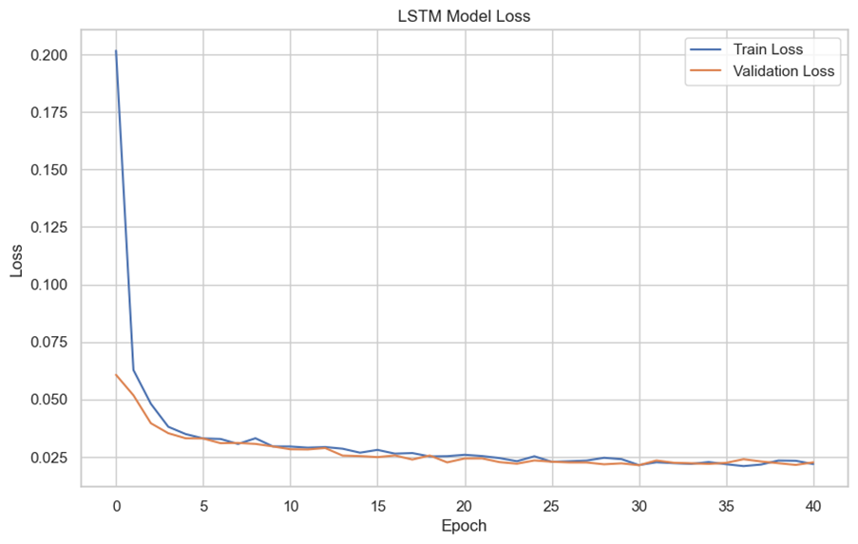

Figure 20 - LSTM Model Loss

Another relevant graph compares actual rental values ​​with predictions made by the model. The proximity between the lines indicates that the model was effective in capturing trends and patterns in the time series data, see Figure 21.

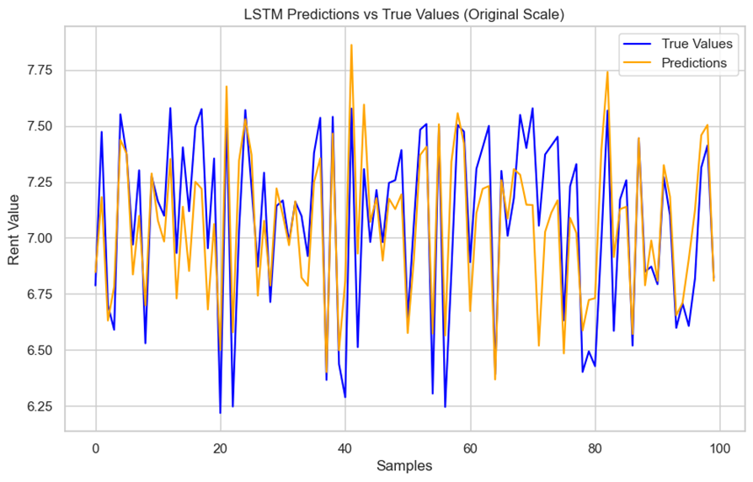

Figure 21 - LSTM Predictions vs True Values (Original Scale)

Overall, the LSTM model with 150 units, a dropout rate of 0.4, a batch size of 32, and a learning rate of 0.005 demonstrated good predictive ability for rental values ​​in a time series. The RMSE of 0.2017 and the MAE of 0.1624 indicate that the model was efficient in accurately predicting rental values ​​while maintaining a good balance between fit and generalization.

### Considerations for the LSTM Model

The LSTM model is effective in predicting trends in the Dublin rental market, with relatively low average errors. However, there are still opportunities to improve performance, particularly in predicting points of high variation in rental values. Additional tuning and the use of more advanced feature engineering techniques could contribute to more accurate and robust predictions.

## Combined Model (RNN + LSTM)

Recurrent neural network (RNN) and LSTM (Long Short-Term Memory) models are widely used in time series forecasting due to their ability to capture sequential dependencies and long-term patterns in the data. RNNs are effective in capturing short-term temporal relationships, while LSTMs were designed to better handle long-term patterns, overcoming the limitation of simple RNNs, which suffer from the gradient fading problem, as discussed by Hochreiter and Schmidhuber (1997).

### Architecture of the combined RNN + LSTM model

The architecture of the RNN + LSTM model was built using the Keras Sequential API and has the Simple RNN layer, with 100 units and ReLU activation, the layer was configured to ensure that the data is processed sequentially and passed on to the next layer. The LSTM layer, containing 150 units, is responsible for capturing the long temporal dependencies in the data. ReLU activation was used to ensure efficient convergence. The Dropout layer, with a dropout rate of 0.4 to prevent overfitting. This layer deactivates 40% of the neurons during training, which helps the model to generalize better to the test data, and finally the Dense Layer, a dense output layer with a single neuron, which generates the final prediction. The model was compiled using the Adam optimizer with a learning rate of 0.005.

### Evaluation Results: RNN + LSTM

The combined RNN + LSTM model with 100 units in the RNN layer, 150 units in the LSTM layer, a dropout rate of 0.4, a batch size of 32, and a learning rate of 0.005 demonstrated good performance in predicting rental values. With an RMSE of 0.1971 and an MAE of 0.1539, the model was able to efficiently capture the temporal dependencies in the time series data.

### Visual Analysis of the RNN Model Combined with LSTM

The graph below shows the evolution of the model loss over the training epochs, both for the training set and the validation set, see Figure 22.

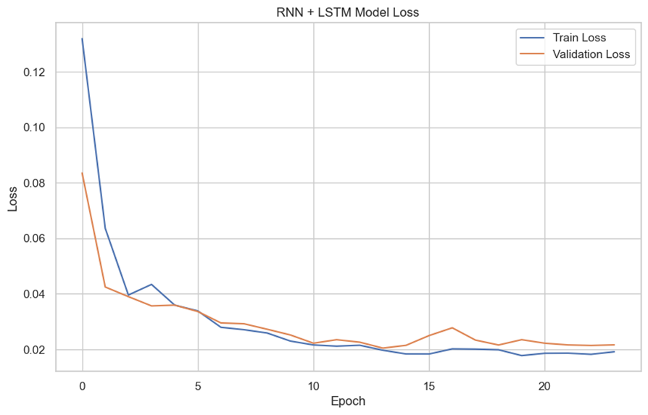

Figure 22 - RNN + LSTM Model Loss

The model loss decreased consistently over time, indicating that the model was able to learn efficiently from the data. The use of early stopping ensured that the model was not overtrained, preventing overfitting.

The graph shown in Figure 23 below compares the model's predictions with the actual rental values. The proximity between the curves indicates that the model was able to predict rental values ​​with a certain degree of relative accuracy over time. It can be seen that the model was able to track fluctuations in the rental data well, demonstrating its ability to generalize.

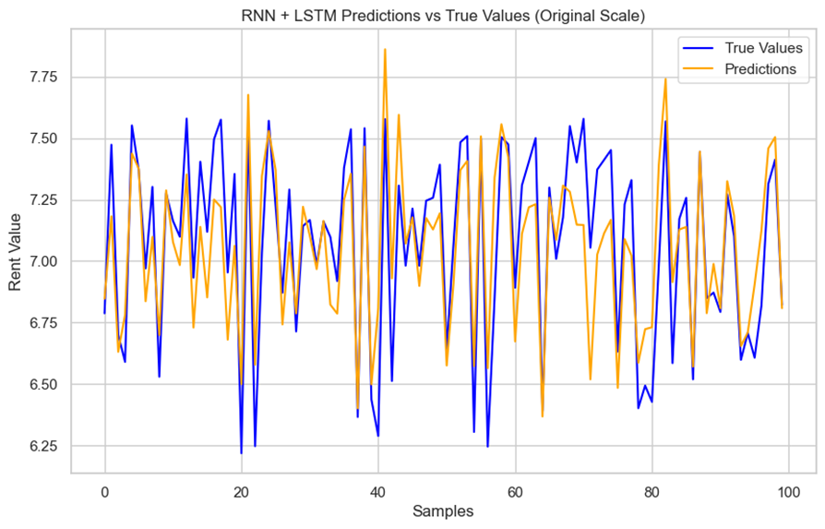

Figure 23 - RNN + LSTM Predctions vs True Values (Original Scale)

## Model Comparison (RNN, LSTM, and RNN + LSTM)

The comparative analysis of the performance of three different neural network architectures: RNN (Simple Recurrent Neural Network), LSTM (Long Short-Term Memory), and the combination of RNN + LSTM. The models were evaluated using the Root Mean Squared Error (RMSE) and Mean Absolute Error (MAE) metrics, which measure the accuracy of predictions relative to the actual values. The performance results for the three models are presented below in Table 3 below.

|  |  |  |  |
| --- | --- | --- | --- |
| **Perfomance Comparison Between Models (RNN, LSTM e RNN+LSTM)** | | | |
|  | **RNN** | **LSTM** | **RNN + LSTM** |
| **RMSE** | 0.2034 | 0.2017 | 0.1971 |
| **MAE** | 0.1613 | 0.1624 | 0.1539 |

Table 3 - Performance Between Models

The RNN + LSTM combination performed best overall among the three architectures, with the lowest RMSE of 0.1971 and the lowest MAE of 0.1539. This indicates that the combined model was more effective in capturing the complex temporal patterns in the time series data, resulting in more accurate predictions.

In addition to the performance metrics, a graph was generated comparing the training loss and validation loss for the three models. This graph helps to understand how each model evolved during training and whether it was able to generalize well to the test data, Figure 24 below.

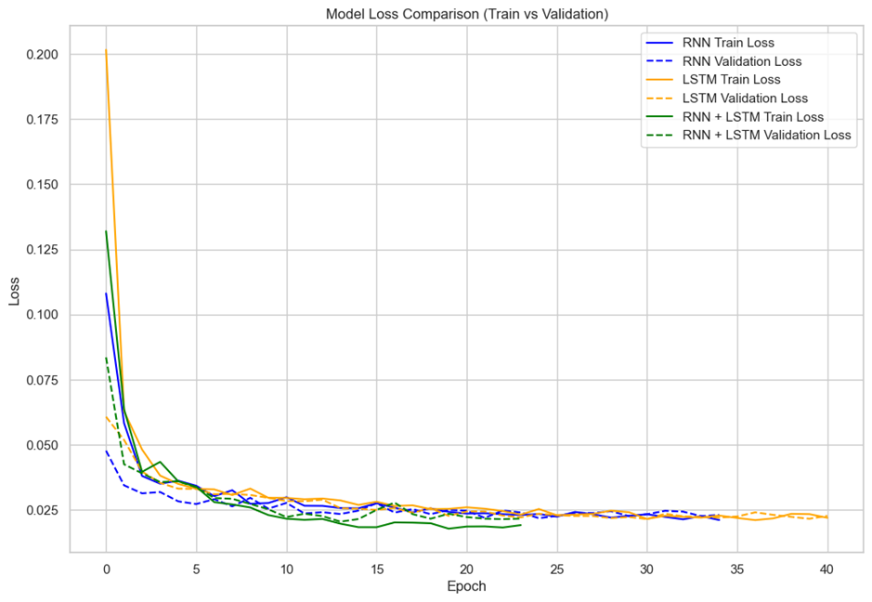

Figure 24 - Model Loss Comparison (Train vs Validation)

The loss curve for the three models shows that all models learned efficiently, with smooth convergence for both training and validation losses. The RNN + LSTM combination had the lowest loss on both the training and validation sets, reinforcing the effectiveness of this hybrid architecture.

### Conclusions from the Evaluation Models

* The RNN model performed reasonably well but had a slightly higher RMSE (0.2034) compared to the other models, indicating that it had more difficulty capturing longer-term temporal dependencies.
* The LSTM model, on the other hand, showed a marginal improvement over the RNN, with an RMSE of 0.2017, suggesting that its ability to capture long-term dependencies had a positive impact on performance.
* The RNN + LSTM model stood out as the best performer among the three, possibly due to its ability to combine the strengths of both architectures, the efficiency of the RNN for short-term patterns, together with the ability of the LSTM to handle long-term dependencies.

### Points to consider for further improvements

Performance could be further improved by adding new variables that influence the rental market, such as economic data or regional factors. Additional hyperparameter testing could lead to more optimized performance, with a combination of different learning rates and batch sizes could yield further improvements, and exploring more advanced hybrid models could potentially improve the capture of seasonal patterns and long-term trends in the data.

### Conclusion of the analyzed models

The combined RNN and LSTM models were effective in predicting rental values ​​in Dublin, outperforming the simple RNN and LSTM versions. The low mean absolute error (MAE) and root mean square error (RMSE) indicate that the combined approach was able to capture the patterns in the data well, making it a viable option for time series forecasting in the real estate context.

## Dublin Forecasts with LSTM + RNN Model and Prediction for 2 and 4 Years

After running three different types of neural network models through training and evaluation results, the model made up of a combination of Recurrent Neural Networks (RNN) and Long Short-Term Memory (LSTM) proved to be the best performer. The model was developed to predict rental values ​​in Dublin using a historical dataset that includes a time series of values ​​over the years. The main idea behind combining RNN and LSTM is to leverage the strengths of both types of networks.

So, from this, we will recreate the model and make short-term forecasts for the next two and four years to understand what may change in the real estate scenario during this period.

### Training and Architecture of the Best Model for Short-Term Forecasting

The data preparation used included historical rental values, using the data set grouped only with data from the city of Dublin called df3 with lags created to represent the time series. The goal was to predict future values ​​based on the patterns observed in the previous 12 months.

Data Normalization was used so that the rental value was scaled to a range between 0 and 1 using sklearn's MinMaxScaler, facilitating the model training process, and the creation of Features with Lag creating 12 lagged features, representing the rental values ​​of the previous 12 months, as input to the model.

The data was divided into a training set up to the year 2022 and a test set using the year 2023, allowing to test the model's ability to predict future values ​​based on historical data.

The model was designed using a combination of an LSTM layer and an RNN layer, allowing the model to capture both long-term dependencies and short-term sequential patterns. The first layer consists of an LSTM with 50 units, used to capture the long-term dependencies in the time series, a Dropout layer with a rate of 20% was used to prevent overfitting, and a single unit in the output layer to predict the future rental value. The model was compiled using the Adam optimizer with a learning rate of 0.01, and the training process was performed with Early Stopping, monitoring the validation loss and stopping the training if there was no improvement after 10 consecutive epochs, preventing overfitting.

* + 1. Model evaluation

During model training, one can understand the interpretation of the evolution in Epoch 1, the model starts with a loss of 0.0014 in the training set and a value of 0.0024 in the validation set. Between Epochs 2 to 10, as the model trains more, the loss continues to decrease consistently, reaching 0.00089 in the tenth epoch for the training set and 0.0018 for the validation. This behavior suggests that the model is managing to learn the patterns of the data and improving its fit, both in the training and validation data.

While in Epochs 11 to 15, the loss continues to decrease, remaining stable around 0.00088 in the training set. However, it is observed that the validation remains around 0.0018, suggesting that the model is maintaining a good balance between the training and validation data, with no signs of overfitting so far.

As for the Early Stopping behavior, monitoring the validation loss resulted in the interruption of training at epoch 21. The final loss on the test set was 0.0018, which indicates that the model was well-trained and generalizes relatively well to new data. This behavior demonstrates that, after epoch 21, there was no significant improvement in the validation loss and, therefore, training was interrupted, avoiding overfitting.

After training, the model was evaluated, the mean absolute error (MAE) was 205.22 and the root mean square error (RMSE) was 258.59, therefore these values ​​indicate that the model had a reasonable performance in predicting the test rent values ​​for 2023, with a mean absolute error of around 205 units in relation to the real values.

The graph shown in Figure 25 below shows the comparison between actual rental values ​​for 2023 and the forecasts generated by the model. The shaded area between the lines represents the forecast error.

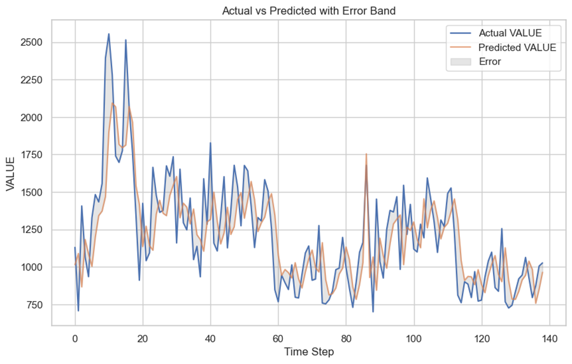

Figure 25 - Actual vs Predicted with Error Band

Using the trained model, forecasts were generated for the next 2 years (24 months) and 4 years (48 months). The model was initialized with the last 12 months of historical data, and subsequent forecasts were made iteratively, where each forecast is used as input for the next.

* **2-Year Forecasts**

The 2-year forecast graph, Figure 26, shows a fluctuating series of predicted values ​​over time. There is considerable volatility in the first few months, where predicted values ​​begin with a sharp drop, followed by peaks and valleys. Short-term variability is greater, indicating that the model predicts fluctuations in the first few months after training. Despite the initial fluctuation, there are moments of stabilization where values ​​remain more consistent, although the oscillatory behavior continues to be present. It can be seen that the highest peak occurs around the 10th month, with values ​​close to 1050, which is followed by a sharp drop. This volatility may indicate that the model is sensitive to short-term trends and may be capturing seasonal patterns or more recent historical variations.

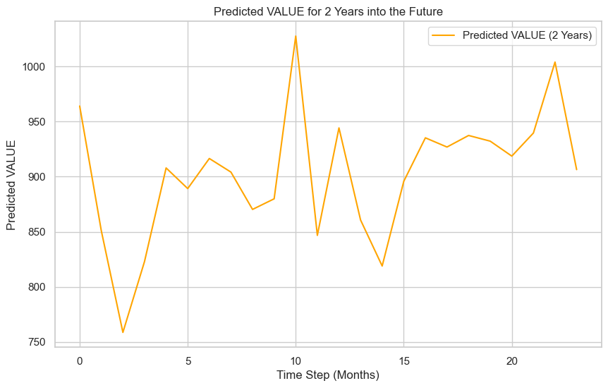

Figure 26 - Predicted Value for 2 Years into the Future

* **4-Year Forecasts**

In the 4-year forecast chart, we can see in Figure 27 below that initially there is a volatility trend similar to that of the 2-year chart, with variations in the first few months. However, after about 15-20 months, the forecasts begin to stabilize, showing a more consistent behavior, with fewer sharp variations. From that point on, the predicted values ​​remain around 900 to 1000, with less abrupt fluctuations and a more gradual growth pattern over time.

This suggests that, while in the short term the model predicts more abrupt fluctuations, in the long term it expects a stabilization of rental values, with a more predictable trend. The model seems to predict a cycle of slight growth in the long term, with peaks stabilizing between averages of 950 and 1000 Euros from the 30th month onwards.

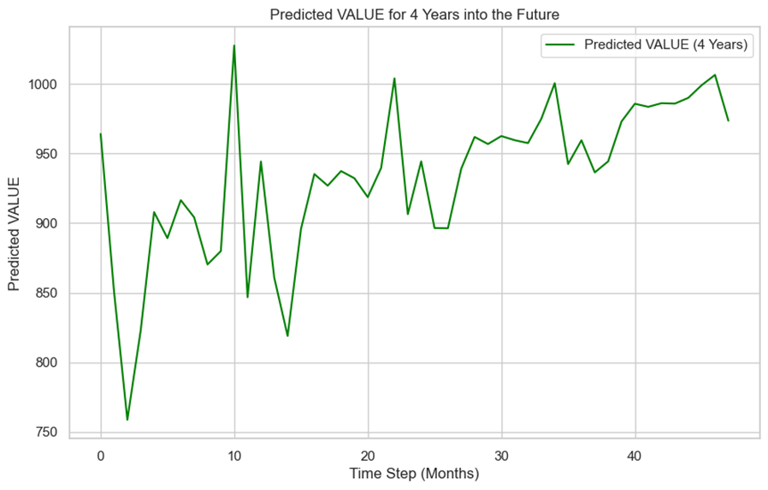

Figure 27 - Predicted VALUE for 4 Years into the future

## Forecasts for Ireland with LSTM + RNN Model and Prediction for 2 and 4 Years

The final process of building, training, and evaluating a combined RNN + LSTM model is applied to the dataset of rental values ​​in Ireland, using the df2 dataset, with the process of training the variables and the predictions for 2 and 4 years in the future. The model building and data preprocessing uses a time series of rental values ​​in Ireland, with the creation of "lag features" (delayed variables) to capture temporal dependencies of up to 12 months. This helps the model to learn seasonal patterns or long-term trends.

Normalization was applied and the values ​​were scaled using MinMaxScaler. The model was trained for up to 100 epochs, using the loss function, and the Early Stopping callback was included to avoid overfitting. The criterion was to monitor validation loss, stop training when the model stopped improving, and restore the best weights.

### Model Evaluation

Evaluating the training performance, the model loss was significantly reduced over the epochs, until reaching a stabilization point around epoch 23, with a final validation of approximately 0.0017, and after the Early Stopping process, the mean squared error in the test set was 0.0017, which indicates good model performance in the test set.

The model evaluation obtained the mean absolute error (MAE) in the test set which was approximately 11.48, while the root mean squared error (RMSE) was 14.42. These are indicators that the model is able to capture the data variation accurately, considering the nature of the rental values.

* **2-Year Forecasts for Ireland**

The graph of the forecasts for 2 years (24 months) into the future, in the Figure 28 below, shows significant variations in the first few months, with both upward and downward fluctuations in the forecast values. This suggests that the model captures both short-term trends and seasonal variations over the period.

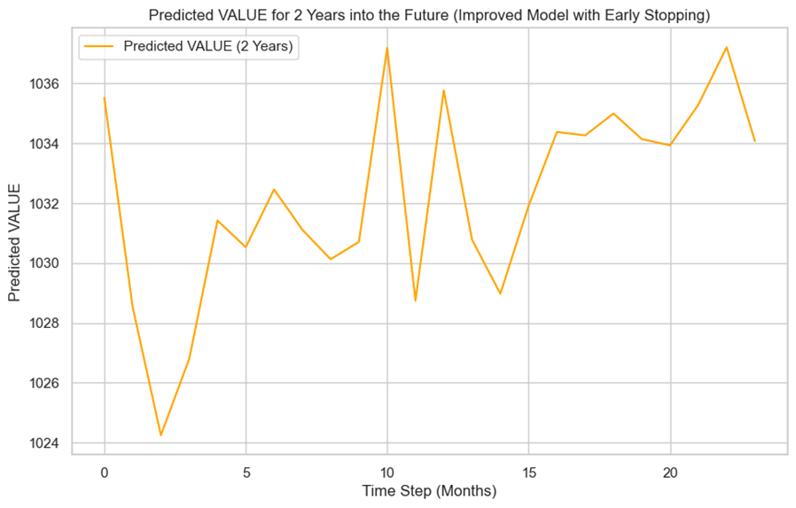

Figure 28 - Predicted VALUE for 2 Years into the Future (Improved with Early Stopping)

* **4-year forecasts for Ireland**

The 4-year (48-month) forecasts show a similar pattern to the 2-year forecast, but with smoother fluctuations, especially after the first 12 months. Predictability increases over time, suggesting that the model expects rental values ​​to stabilize in the long term, as shown in Figure 29 below.

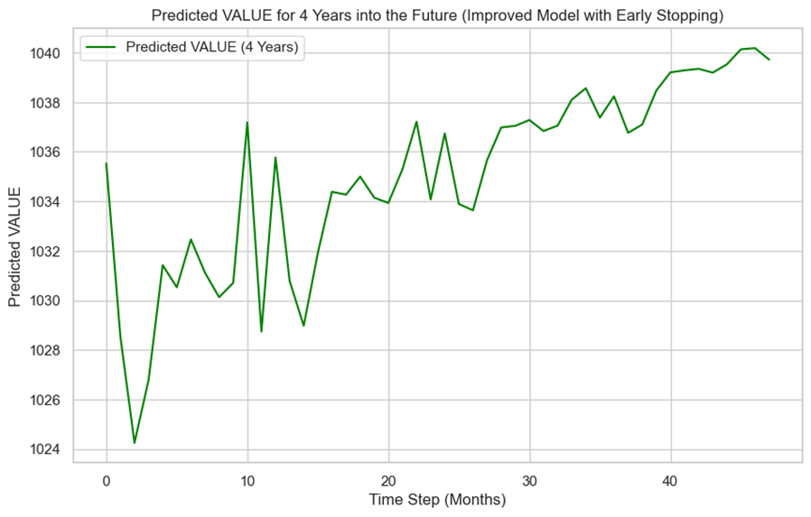

Figure 29 - Predicted Value For 4 Years into the Future (Improved with Early Stopping)

The RNN+LSTM model performed remarkably well in capturing both short-term variations and long-term trends in Irish rental values. The use of techniques such as Early Stopping was essential to prevent overfitting, allowing the model to generalize better to the test set. The 2- and 4-year forecasts suggest that the rental market may experience cyclical variations in the early years, but tends to stabilize into a more predictable pattern in the long term.

## Implications for Future Research

The lack of complete data in the most critical crisis years means that long-term forecasts do not adequately capture market fluctuations. This has a direct impact on investment strategies and public policy decisions, potentially resulting in an undervalued or overvalued market.

# Conclusion

The study of the Dublin rental market, which focused on the period 2008 to 2023, provides a comprehensive overview of the main trends and price variations in the different areas of the city. The primary research revealed that macroeconomic factors, such as the 2008 crisis and the COVID-19 pandemic, played a key role in the fluctuation of rental prices, especially in the central areas. Historical analysis of the data showed a significant recovery of the market after the crisis periods, with significant price increases between 2015 and 2019, followed by a slowdown due to the pandemic.

By comparing regions and property types, a substantial disparity in rental prices was identified, reflecting the complexity and heterogeneity of the Dublin property market. The numerical results show that between 2008 and 2023, the average increase in rental prices in Dublin was approximately 70%. The period of greatest growth occurred between 2015 and 2019, with annual growth rates exceeding 8%, reaching 10% in peripheral areas. During the 2020 pandemic, prices fell by around 5.6% in the city center, but have grown more moderately since 2021, averaging 2.5% per year.

Finally, the data processing study using the database provided by the RTB highlighted the importance of robust methods for dealing with missing data and the need for a second phase of analysis to deepen the understanding of market variations. During development, a major challenge related to data quality was identified: approximately 65% ​​of the values ​​were missing, requiring the application of advanced imputation techniques. Different strategies were employed, such as imputation based on the annual mean and location, and the global median for the remaining cases. This ensured that the dataset was suitable for the modeling stages.

The performance of the models was evaluated using metrics such as Root Mean Squared Error (RMSE) and Mean Absolute Error (MAE). The best results were obtained with the combined RNN and LSTM model, which presented an RMSE of 0.1971 and an MAE of 0.1539. This model was able to capture both short-term fluctuations and long-term trends in the rental market.

# Analysis and Insights

**Impact of Missing Data:** The significant lack of data imposed limitations on the accuracy of the model, especially for the period 2008 to 2012. However, the applied imputation techniques proved effective in mitigating these issues, allowing the construction of an acceptable data set for modeling.

**Volatility Patterns:** The rental market in Dublin, as shown by the heteroscedasticity tests, has shown variations in volatility over time, reflecting economic and social conditions, such as the recovery from the financial crisis and the impact of the COVID-19 pandemic.

**Forecast:** Forecasts generated for the next two and four years indicate moderate growth in rental values, with significant variations between different regions of Dublin. More central regions will continue to experience significantly higher rents, driven by high demand and limited supply.

# Practical Contributions of the Study

This work provides a practical contribution to understanding the impact of missing data on rent forecasts and shows how data imputation can mitigate, but not eliminate, the effects of missing information. Furthermore, the use of neural networks, especially LSTM, has proven to be a robust approach for time series forecasting, but its effectiveness is limited by the quality of the input data.

## Suggestions for Future Studies

Feature engineering: Performance could be further improved by adding new variables that influence the rental market, such as economic data or regional factors.

Hyperparameter fine-tuning: Additional hyperparameter testing may lead to optimized performance. Combining different learning rates and batch sizes may yield additional improvements.

Future work should explore the use of alternative data, such as economic indicators and housing censuses, to fill data gaps. In addition, hybrid techniques that combine neural networks with traditional models may offer improvements in predictions, especially in scenarios where data shortages are a significant challenge.

# References

Amrullah, A. (2023) ‘A Deep Dive into LSTM Neural Network-based House Rent Prediction’, *Analytics Vidhya*, 5 June. Available at: https://www.analyticsvidhya.com/blog/2023/06/a-deep-dive-into-lstm-neural-network-based-house-rent-prediction/ (Accessed: 19 May 2024).

Annamoradnejad, R. and Annamoradnejad, I. (2022) ‘Machine Learning for Housing Price Prediction’, in, pp. 2728–2739. Available at: https://doi.org/10.4018/978-1-7998-9220-5.ch163.

Book (eISB), electronic I.S. (no date) *electronic Irish Statute Book (eISB)*. Office of the Attorney General. Available at: https://www.irishstatutebook.ie/eli/2018/act/7/enacted/en/html (Accessed: 27 September 2024).

Casolaro, A. *et al.* (2023) ‘Deep Learning for Time Series Forecasting: Advances and Open Problems’, *Information*, 14(11), p. 598. Available at: https://doi.org/10.3390/info14110598.

Costigan-Eaves, P. (1986) ‘Edward R. *Tufte The visual display of quantitative information*’, *Information Design Journal*, 4(3), pp. 235–236. Available at: https://doi.org/10.1075/idj.4.3.12cos.

‘Crisp DM methodology’ (no date) *Smart Vision Europe*. Available at: https://www.sv-europe.com/crisp-dm-methodology/ (Accessed: 27 September 2024).

*General Data Protection Regulation (GDPR) – Legal Text* (no date) *General Data Protection Regulation (GDPR)*. Available at: https://gdpr-info.eu/ (Accessed: 27 September 2024).

Hosford, P. (2022) *War on Ukraine to impact housing but O’Brien insists Ireland will meet its targets*, *Irish Examiner*. Available at: https://www.irishexaminer.com/news/arid-40846334.html (Accessed: 19 May 2024).

*Ireland’s housing crisis facts and figures: All you need to know* (2023) *The Irish Times*. Available at: https://www.irishtimes.com/ireland/housing-planning/2023/03/23/irelands-housing-crisis-facts-and-figures-all-you-need-to-know/ (Accessed: 19 May 2024).

*Irish Rental Report Q2 2024 | Daft.ie* (no date). Available at: https://ww1.daft.ie/report?d_rd=1 (Accessed: 27 September 2024).

Khrais, L.T. and Shidwan, O.S. (2023) ‘The role of neural network for estimating real estate prices value in post COVID-19: a case of the middle east market’, *International Journal of Electrical and Computer Engineering (IJECE)*, 13(4), pp. 4516–4525. Available at: https://doi.org/10.11591/ijece.v13i4.pp4516-4525.

Martin, L.-C. (2019) *Machine Learning vs Traditional Forecasting Methods: An Application to South African GDP*. Working Paper 12/2019. Stellenbosch University, Department of Economics. Available at: https://econpapers.repec.org/paper/szawpaper/wpapers326.htm (Accessed: 19 May 2024).

McDermott, K. (2023) *The gateway to the EU: Why Dublin became a bustling tech hub*, *euronews*. Available at: https://www.euronews.com/next/2023/02/02/the-gateway-to-the-eu-why-dublin-became-a-bustling-tech-hub (Accessed: 19 May 2024).

Montenegro, I. (2019) *5 tips for defining better business objectives*, *GB Advisors*. Available at: https://www.gb-advisors.com/business-objectives/ (Accessed: 27 September 2024).

*Residential Property Price Index September 2020 - Central Statistics Office* (2020). CSO. Available at: https://www.cso.ie/en/releasesandpublications/ep/p-rppi/residentialpropertypriceindexseptember2020/ (Accessed: 19 May 2024).

*Traditional Forecasting Models And Their Limitations* (no date) *FasterCapital*. Available at: https://fastercapital.com/keyword/traditional-forecasting-models-and-their-limitations.html (Accessed: 19 May 2024).

*Enders, W. (2004). Applied Econometric Time Series. 2nd ed. Hoboken: John Wiley & Sons.*

*Brownlee, J. (2024). A Gentle Introduction to Autocorrelation and Partial Autocorrelation. Available at*: https://machinelearningmastery.com

*Frost, J. (2024). Autocorrelation and Partial Autocorrelation in Time Series Data. Available at*: <https://statisticsbyjim.com>

*Hochreiter, S., & Schmidhuber, J. (1997). Long Short-Term Memory. Neural Computation*, 9(8), 1735-1780.

*Frost, J. (2024). Spearman's Correlation Explained. Available at:* [*https://statisticsbyjim.com*](https://statisticsbyjim.com)

*Hochreiter, S., & Schmidhuber, J. (1997). Long Short-Term Memory. Neural Computation, 9(8), 1735-1780.*

*Breusch, T. S., & Pagan, A. R. (1979). "A Simple Test for Heteroscedasticity and Random Coefficient Variation". Econometrics, 47(5), 1287–1294.*

*Shapiro, S. S., & Wilk, M. B. (1965). "An analysis of variance test for normality (complete samples)". Biometrika, 52(3-4), 591–611.*

*Shapiro, S. S., & Wilk, M. B. (1965). "An analysis of variance test for normality (complete samples)". Biometrika, 52(3-4), 591–611.*

# Appendix

**Appendix 1**

* **Primary Research insights**

**Study of 2008**

The 2008 study found that the Dublin rental market suffered significant declines due to the global financial crisis at the time. Rents across Ireland fell dramatically, with Dublin being the worst hit. Nationally, rents fell by almost 12% during the year, with half of the decline occurring in the last quarter of 2008. In Dublin, rents fell by an average of 13.1%, with some areas experiencing even steeper declines. The oversupply of rental properties on the market due to the economic downturn contributed to these declines.



**Economic Insights:**

* **Oversupply in the Rental Market**: The rental market saw a surge in supply with over 20,000 properties available by the end of 2008, double the figure earlier in the year. This massive oversupply, coupled with weakening demand, led to a steep fall in rents.
* **Impact on the Middle Class**: Middle-class areas in Dublin were hit hardest by the rental price declines, with South Dublin County seeing a 15.2% drop in rents.

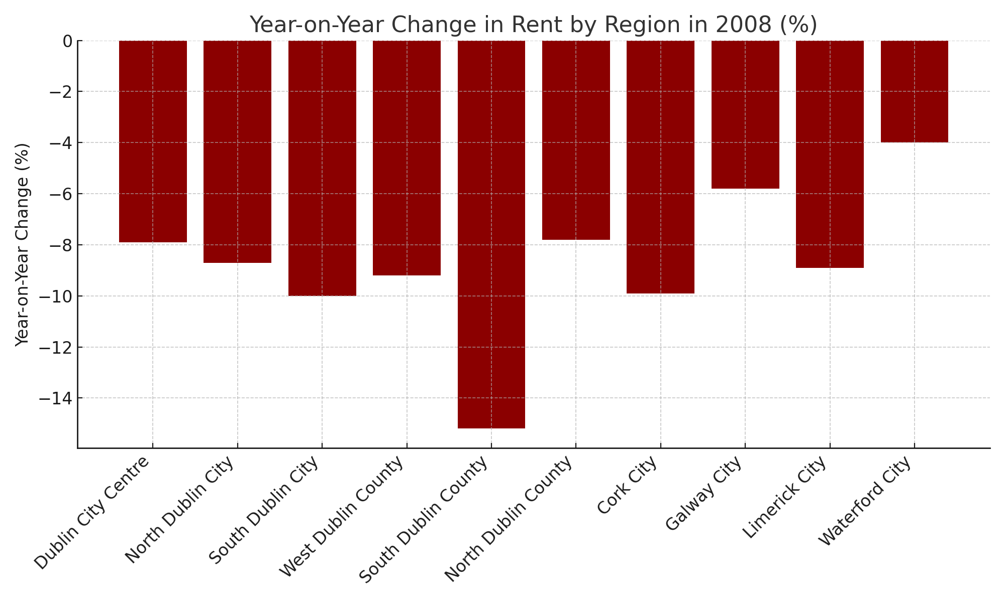

**Study of 2009**

In 2009, rental prices in Ireland fell significantly, with a national decline of over 15%. Dublin experienced larger declines than other regions, with city centre rents falling by 20.6% and the overall decrease in Dublin averaging 19-21%. The supply of rental properties also fell by 20%, reducing competition between landlords.



**Economic Insights:**

* **Urban-Rural Divide**: Urban areas like Dublin saw larger rent declines than rural areas. The falls were steep in Cork and Galway as well.
* **Supply Reduction**: The number of rental properties fell sharply, indicating a tightening market.

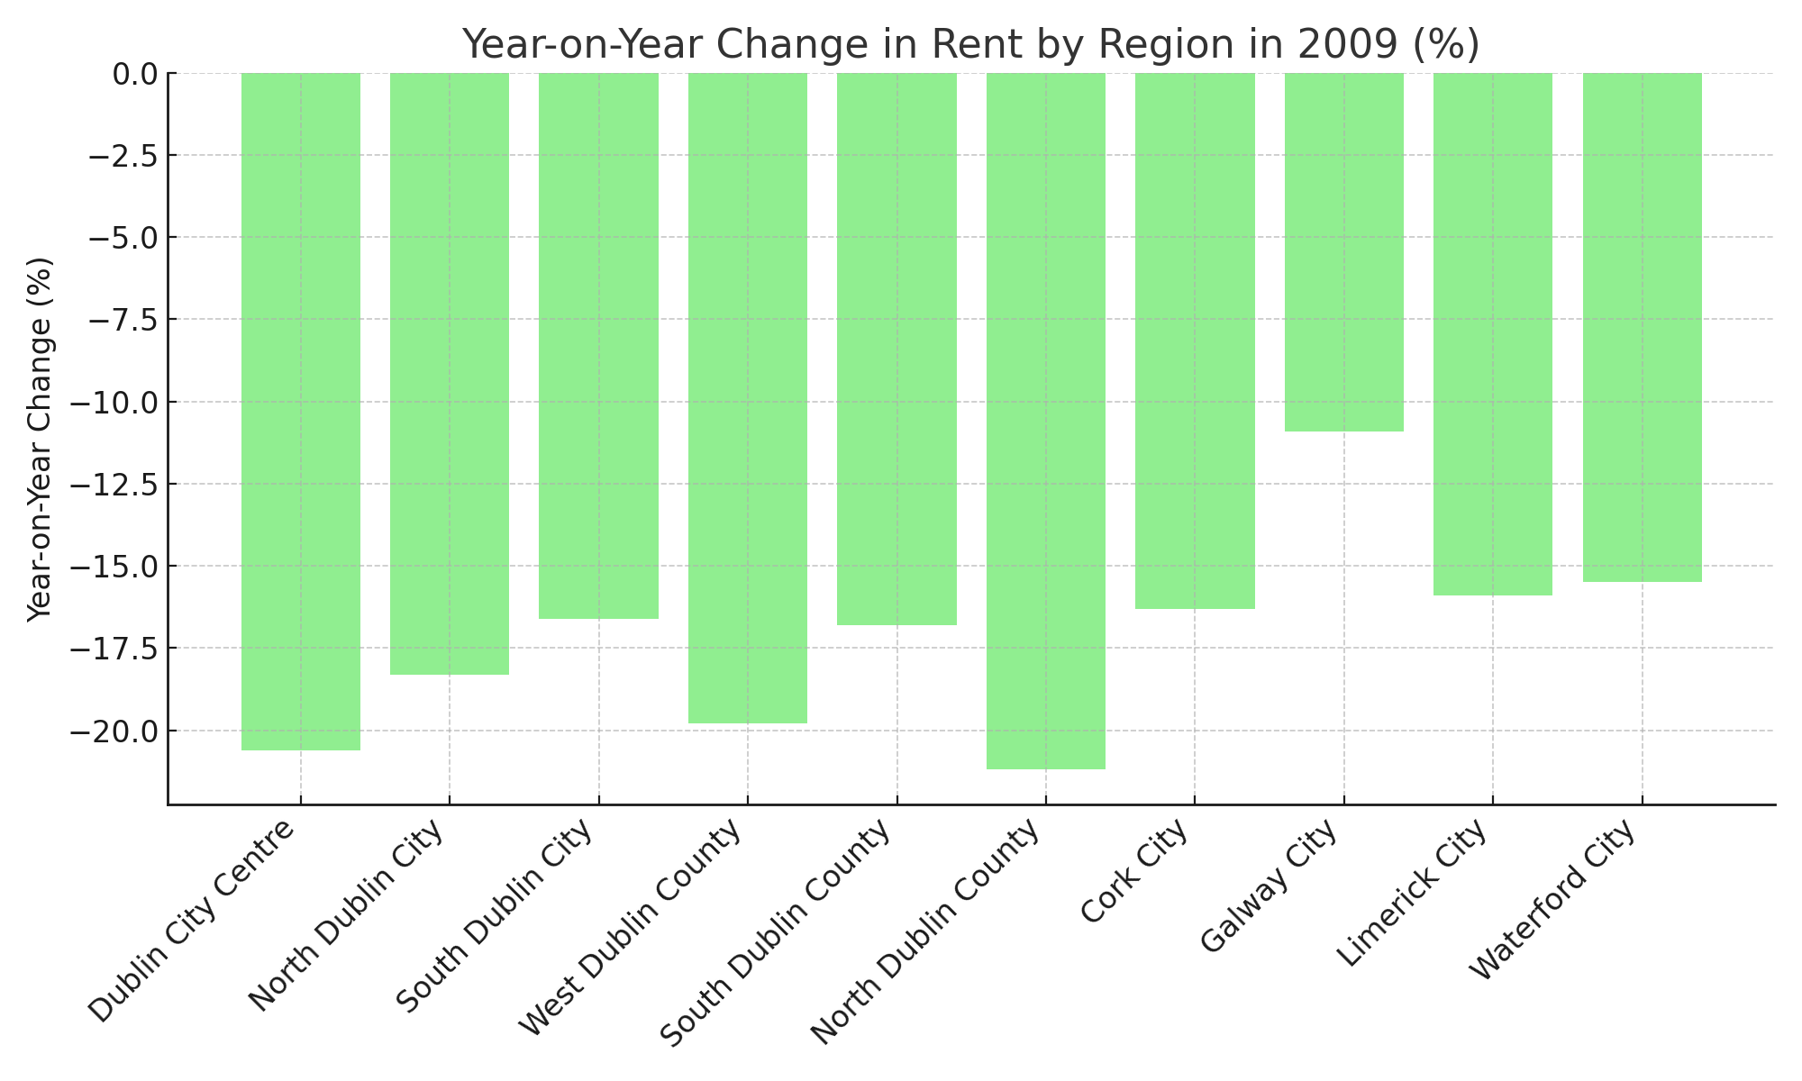

**Study of 2010**

In 2010, rental prices in Ireland showed slight reductions, with the national average rent falling by 0.6% to €830. Dublin saw more stability, with rents in the capital showing a slight increase of 0.3%, while other areas of the country saw rents fall more significantly. The most pronounced differences were between city center rents, which remained stable or increased.



**Key Factors Influencing the 2010 Rental Market:**

* **Economic Impact**: The report emphasized the ongoing economic downturn, a critical driver for rent reductions outside of Dublin. Emigration forecasts suggested 100,000 people would leave Ireland over the next two years, affecting rental demand in commuter areas more than in the city.
* **Doughnut Effect**: Higher demand in the city center resulted in stabilized or slightly rising rents, while outer areas saw rent declines as tenants moved towards urban centers.

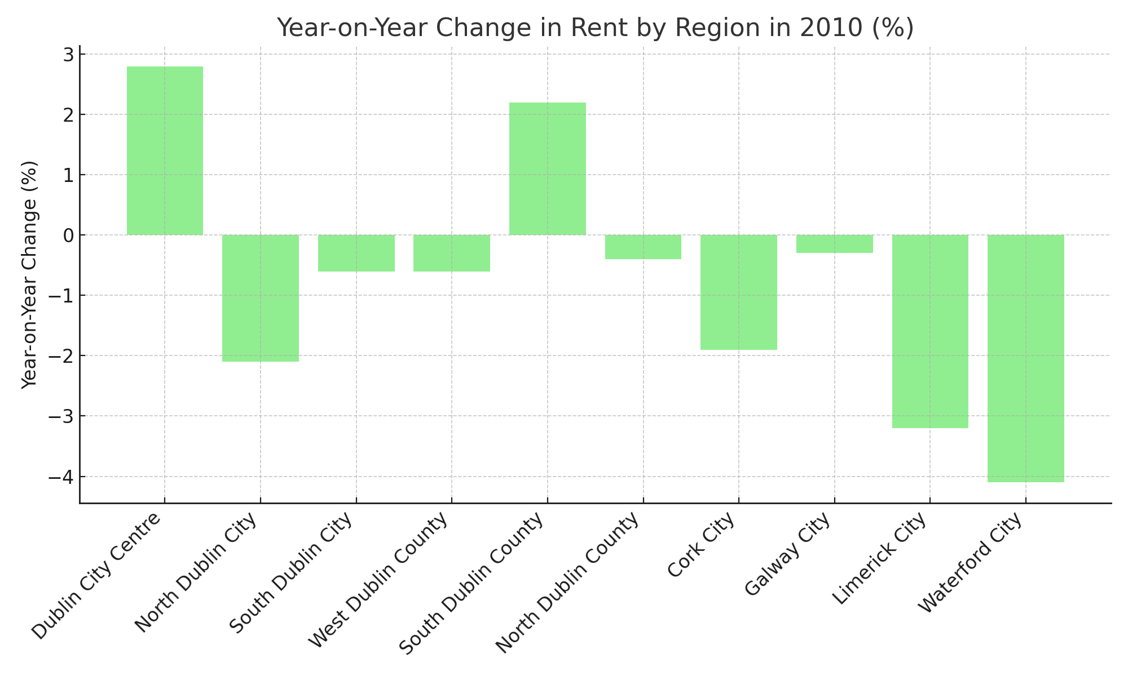

**Study of 2011**

In 2011, rents in Dublin and other urban areas slightly increased, while rural areas saw small decreases. The national average rent in January 2012 was €821, slightly higher than the previous year. The supply of rental properties was at its lowest level since 2008, largely driven by a decline in Dublin.



**Economic Insights:**

* **Urban-Rural Divide**: Urban areas like Dublin, Cork, and Galway saw modest rent increases, while rural regions faced rent declines of around 1-3%.
* **Supply Reduction**: The number of properties available for rent in Dublin declined significantly, reflecting higher demand.

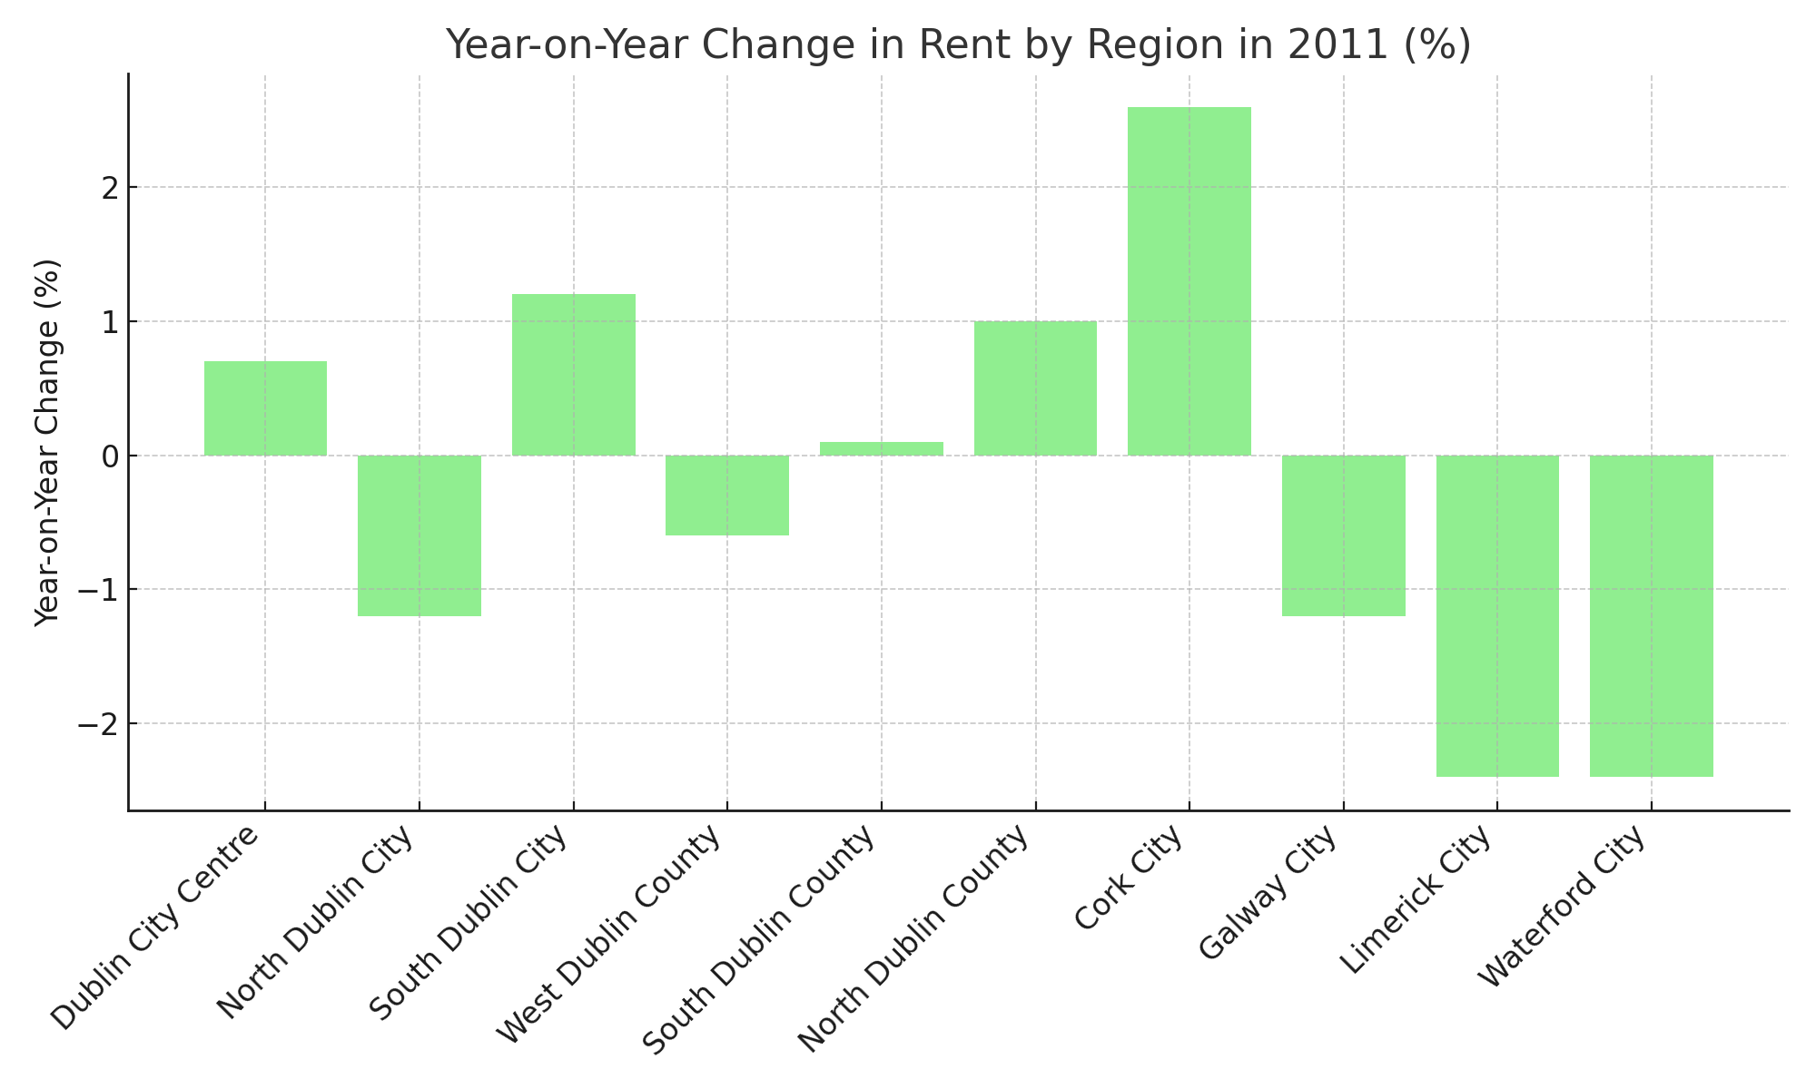

**Study of 2012**

In 2012, rents rose nationally by 2.2%, marking the first significant increase since the market crash. Rent growth was particularly notable in urban areas, with Dublin leading the way at 4.9%. Meanwhile, rural areas continued to experience declines, illustrating the ongoing urban-rural divide in the rental market.



**Economic Insights:**

* **Urban-Rural Divide**: The strong rent increases in Dublin contrasted with stagnant or declining rents in rural areas. The number of properties available to rent was at its lowest since mid-2008.

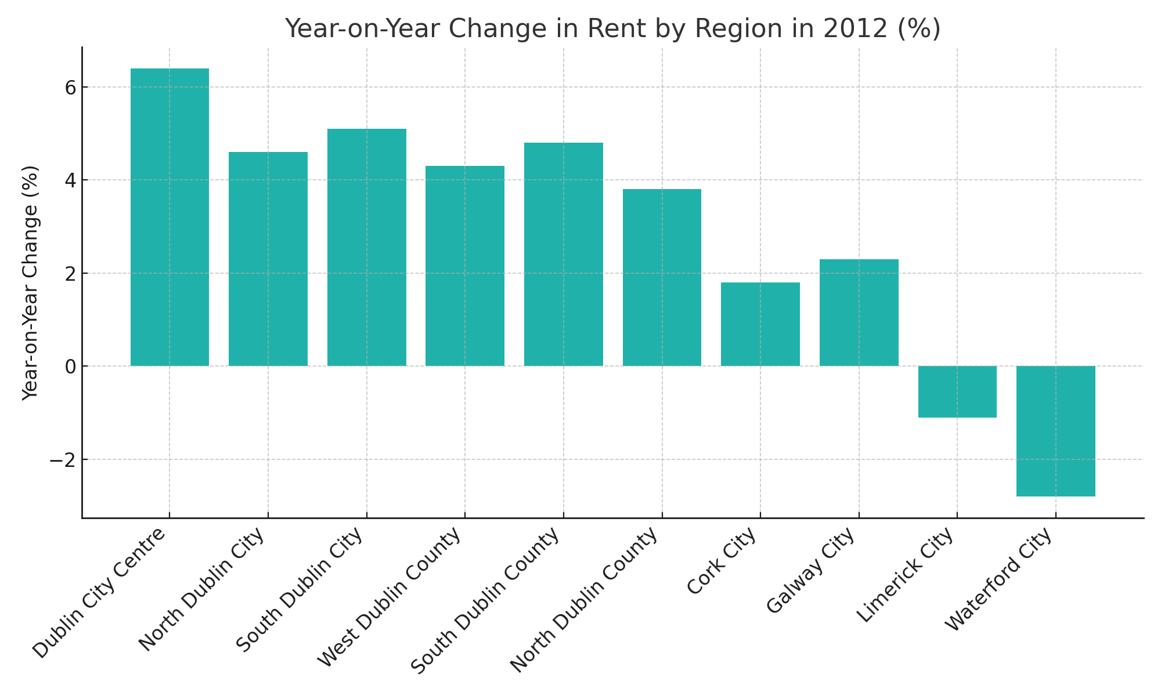

**Study of 2013**

In 2013, rents in Dublin saw a sharp rise, with the capital witnessing double-digit rental inflation. Overall, rents across Ireland rose by 7.1%, marking the strongest annual growth since 2006. The upward pressure on rents was particularly acute in Dublin due to limited supply, with fewer than 1,500 properties available for rent by the end of the year.



**Economic Insights:**

* **Supply Shortage**: The demand for rental properties in Dublin far outstripped supply, driving up rents significantly. Low levels of new housing construction further exacerbated this.
* **Regional Variation**: While Dublin experienced sharp increases, rents in rural areas and smaller cities remained relatively stable.

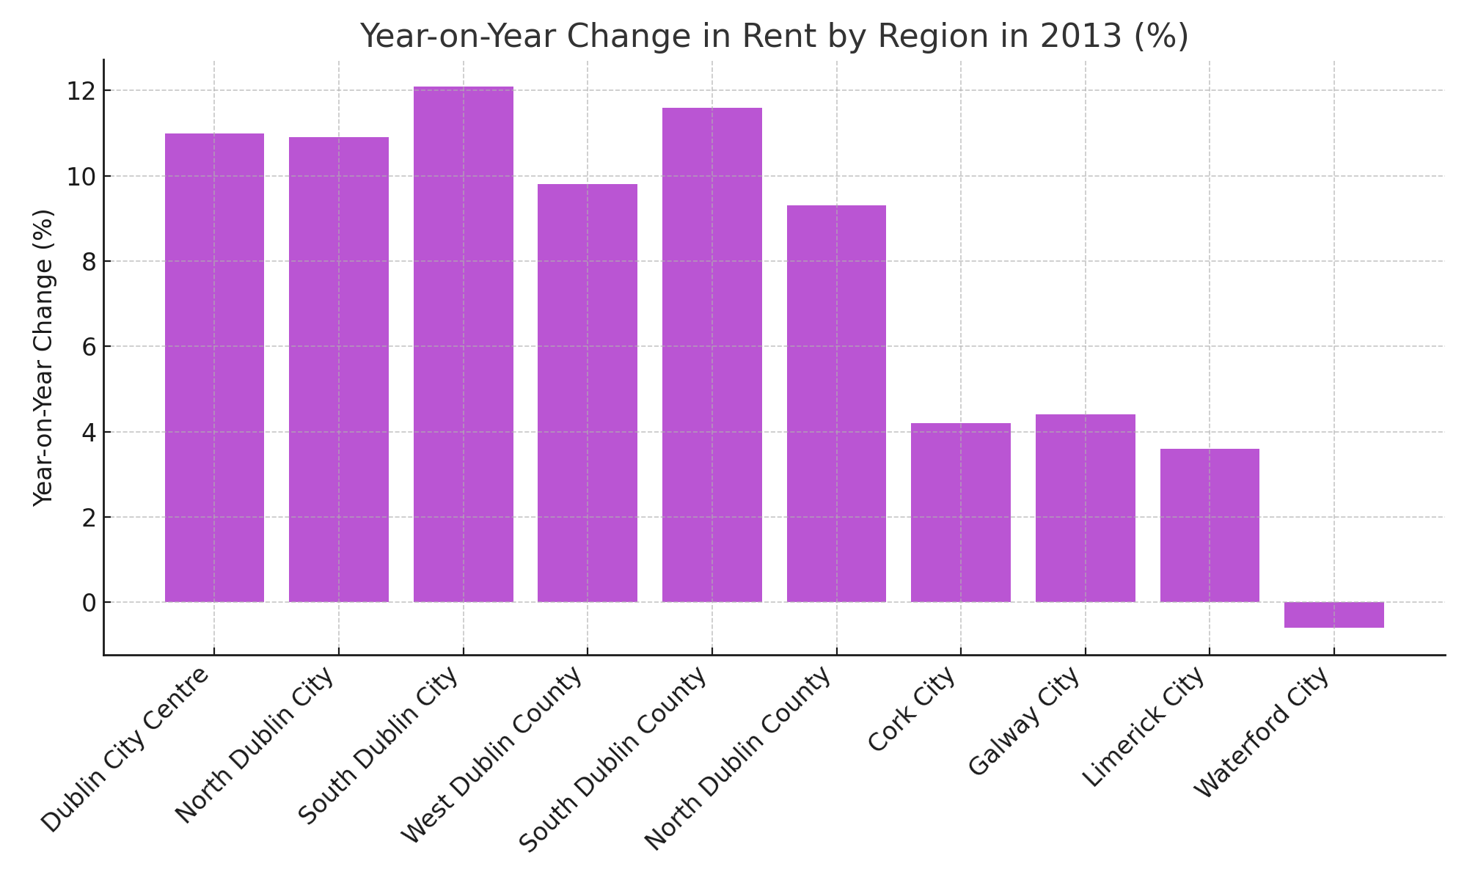

**Study of 2014**

In 2014, rents continued to rise in Ireland, but the rate of rent inflation slowed slightly for the first time since 2009. Nationally, rents were 9.7% higher in the last quarter of 2014 than in the same period in 2013. Rental shortages continued to push up prices, particularly in Dublin, where rents rose by almost 13.6%.



**Economic Insights:**

* **Urban Affordability Challenges**: The rental affordability gap widened, driving some renters to commuter towns. As a result, inflation in commuter counties exceeded Dublin for the first time in five years.
* **Stock Decline**: The rental stock fell to its lowest levels since 2007, with only 5,200 properties available nationwide by February 1st, 2015.

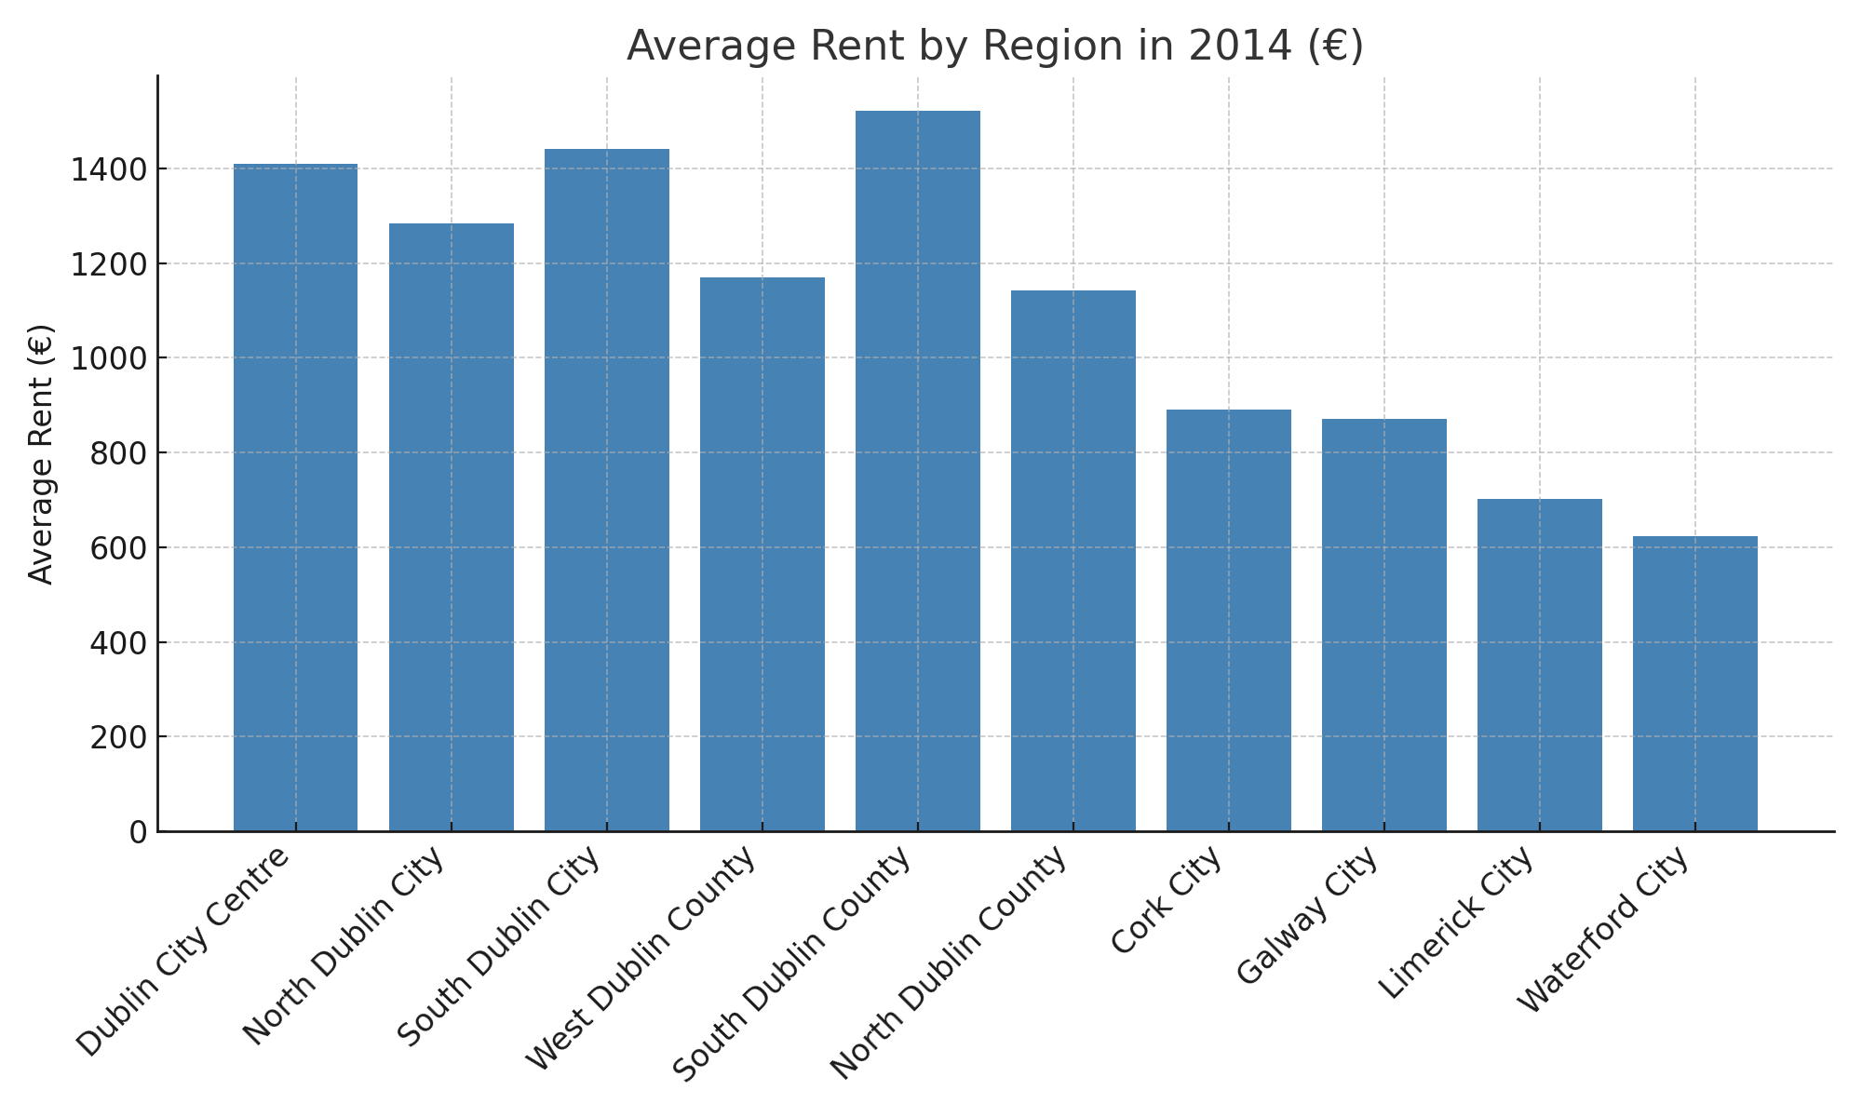

**Study of 2015**

In 2015, rental prices across Ireland continued to rise for the 14th consecutive quarter. Nationally, rents increased by 9% compared to 2014, with Dublin experiencing an increase of 8.2%. The rental market remained severely undersupplied, particularly in Dublin, where fewer than 1,400 properties were available to rent in February 2016.



**Economic Insights:**

* **Rental Market Pressures**: Demand far outstripped supply, especially in urban areas. The capital's rent levels grew more moderately compared to previous years, but rents were still nearing their peak levels from 2008.
* **Supply Challenges**: The report highlighted that fewer than 3,600 properties were available for rent nationwide, the lowest figure since 2006.

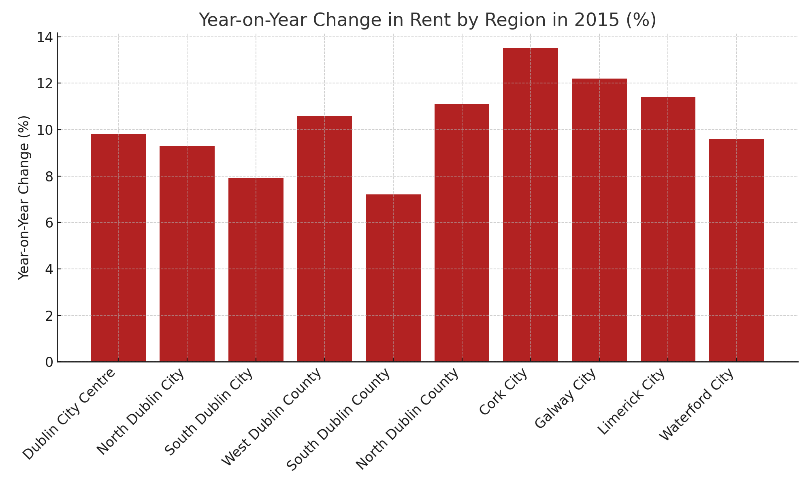

**Study of 2016**

In 2016, rental prices continued to rise, marking the highest annual rate of rent inflation since the Daft report began in 2002. Nationally, rents rose by 13.5%, with Dublin rents rising even more sharply, by 14.5%. Supply shortages persisted, with fewer than 4,000 homes to rent available across the country at the start of 2017.



**Economic Insights:**

* **Severe Supply Shortage**: The availability of rental properties remained near record lows, with Dublin experiencing the sharpest rent increases due to high demand.
* **Room Costs**: Costs for single and double rooms in shared accommodations also saw increases, up 10% during 2016

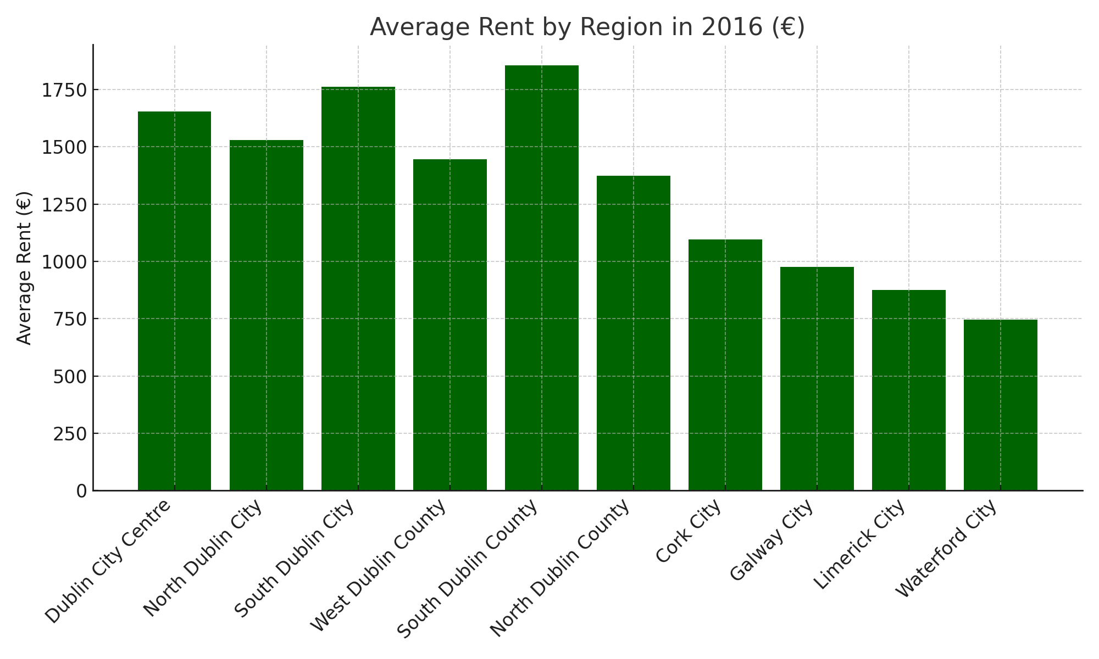

**Study of 2017**

In 2017, rents in Ireland saw another year of significant increases, with the national average rent rising by 10.4%. In Dublin, rents grew by 10.9%, continuing a streak of double-digit increases. Rental availability remained tight, with fewer than 3,150 properties available nationwide, marking a 15% drop compared to 2016.



**Economic Insights:**

* **Supply Constraints**: A continuing shortage of rental properties was a driving force behind the rent increases, especially in Dublin, where rental stock fell by 15% compared to 2016.
* **Urban Affordability**: The cost of renting in Dublin is now 90% higher than in 2010

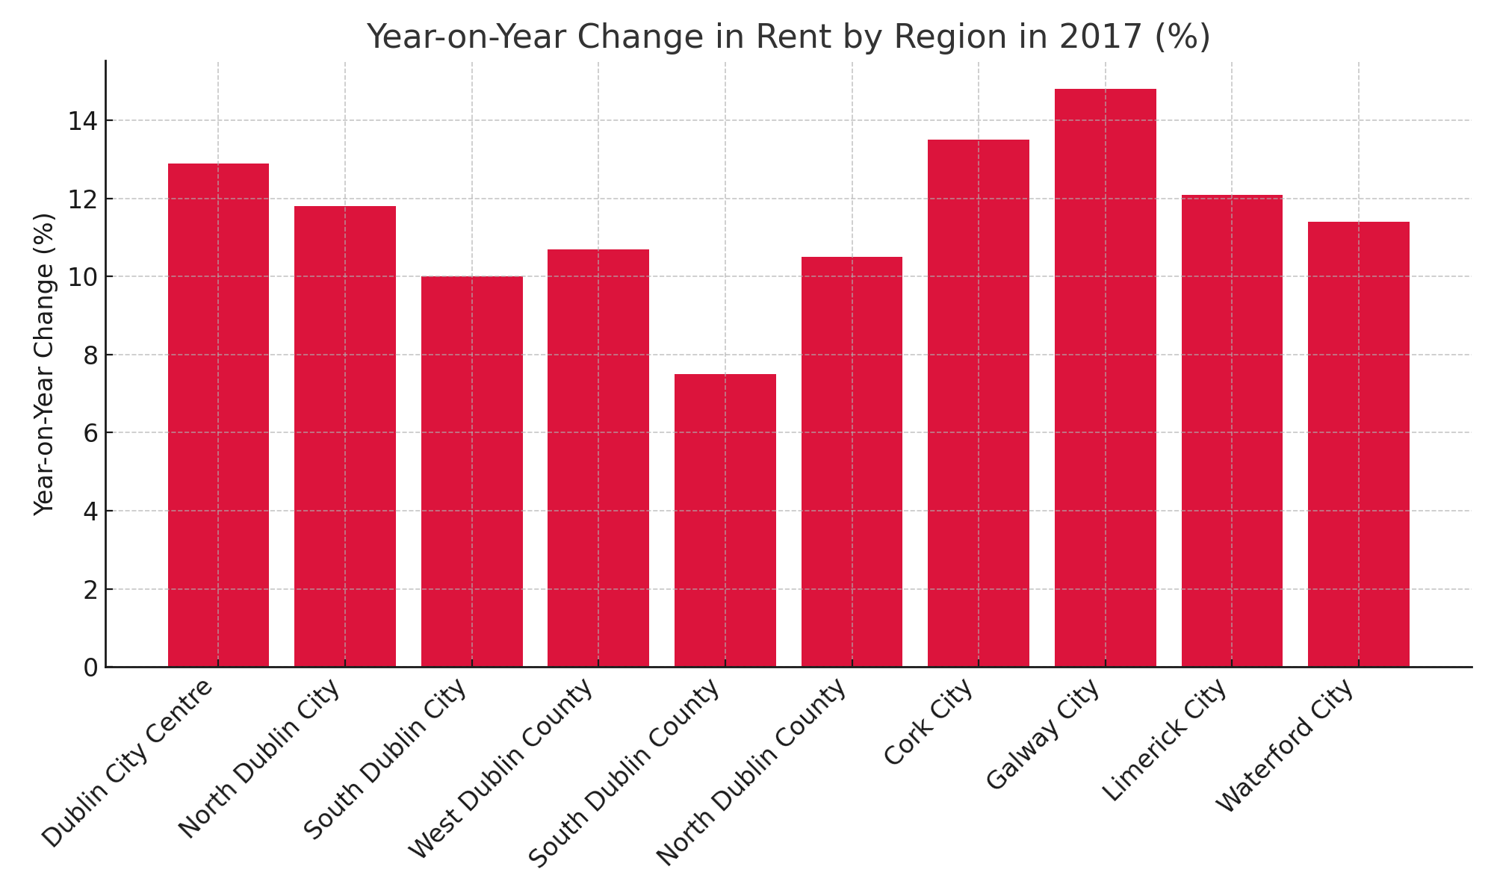

**Study 2018**

In 2018, the rental market in Ireland continued its upward trajectory with record rent increases. Nationally, rents increased by 9.8% compared to the previous year. Dublin, being the worst affected area, saw average rents surpass the €2,000 mark in some areas for the first time, driven by high demand and limited supply.



**Economic Insights:**

* **Record High Rents**: Dublin rental prices reached unprecedented levels in 2018, with several areas crossing the €2,000/month threshold, reflecting a major housing supply issue.
* **Double-Digit Growth**: Other cities such as Limerick and Waterford also saw significant rent inflation, with increases of 16.7% and 16.0%, respectively.
* **Commuter Impact**: As affordability in Dublin worsened, there was a noticeable spillover effect on commuter areas, pushing rents higher in regions surrounding the city.

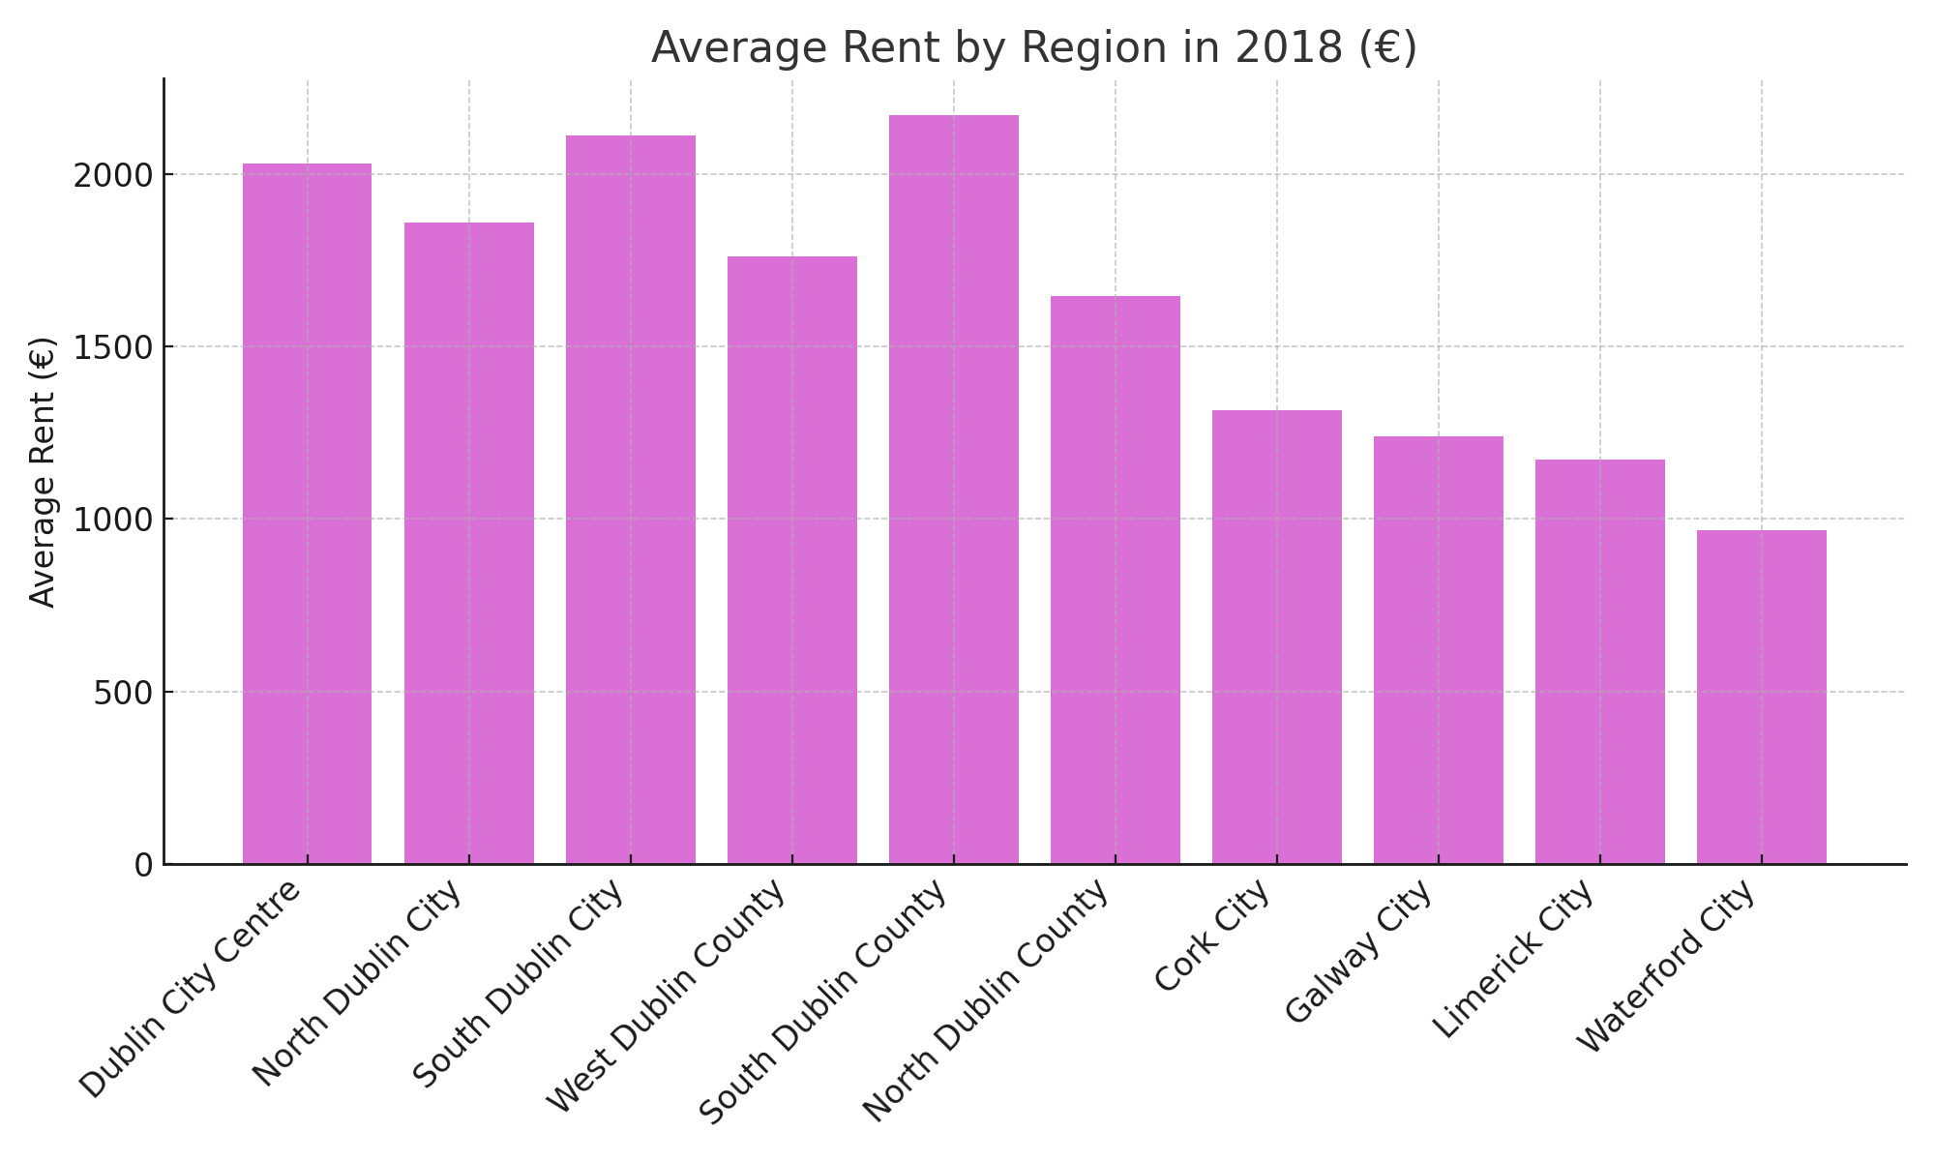

**Study of 2019**

In 2019, the rental market in Dublin showed signs of moderation. Although rents continued to rise, the pace of growth slowed compared to previous years. Nationally, rents were 4.1% higher than in 2018, marking the lowest rate of inflation since 2012. In Dublin, rents increased by 3.5%, with rents rising modestly in the last quarter of 2019.



**Economic Insights:**

* **Cooling Rent Inflation**: 2019 marked the first time in seven years that rent inflation was below 4% in Dublin. This slowdown occurred despite the continued supply challenges in the city, indicating a possible market stabilization.
* **Rental Affordability**: The rent freeze discussions were central to the national debate, especially with the ongoing affordability crisis, though no decisive policies had been enacted by the year's end.

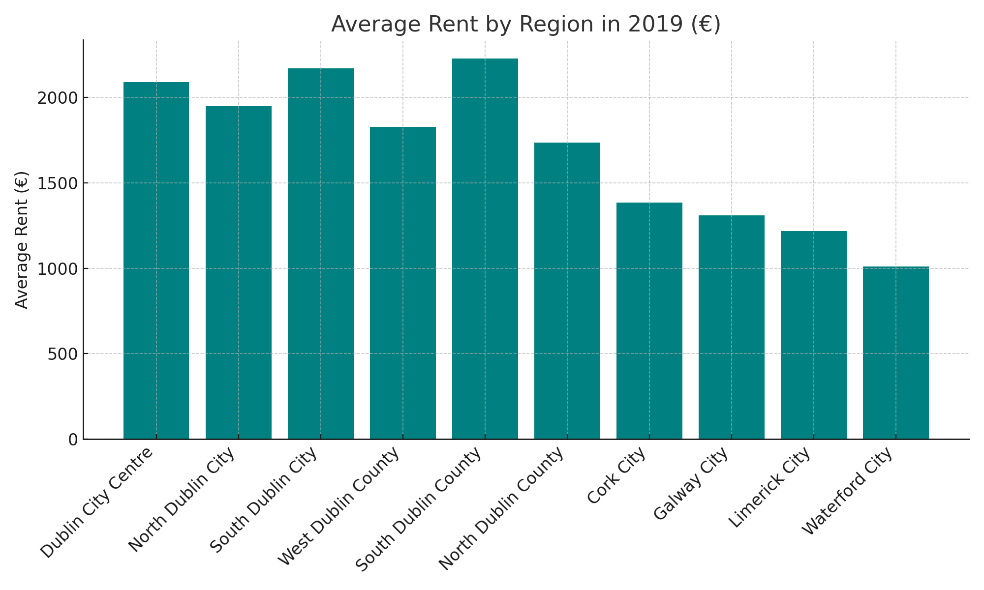

**Study of 2020**

The COVID-19 pandemic significantly impacted Dublin’s rental market in 2020, causing the first annual decline in rents since 2010. Rents in Dublin fell by 3.3%, marking a stark contrast to the rest of Ireland, where rents increased by 5.4%. The economic downturn, movement restrictions, and an increase in rental supply (due to the conversion of short-term to long-term rentals) were key factors in this decline.



**Economic Insights:**

* **COVID-19 Impact**: The pandemic's effect on Dublin's economy, particularly the collapse in everyday activities, drove down demand in the rental market. This created a stark contrast with the rest of the country, where rental prices continued to rise.
* **Increased Supply**: The supply of rental homes in Dublin surged by 64% by the end of 2020, with 2,600 homes available to rent. This marked the highest supply level in Dublin since 2012.

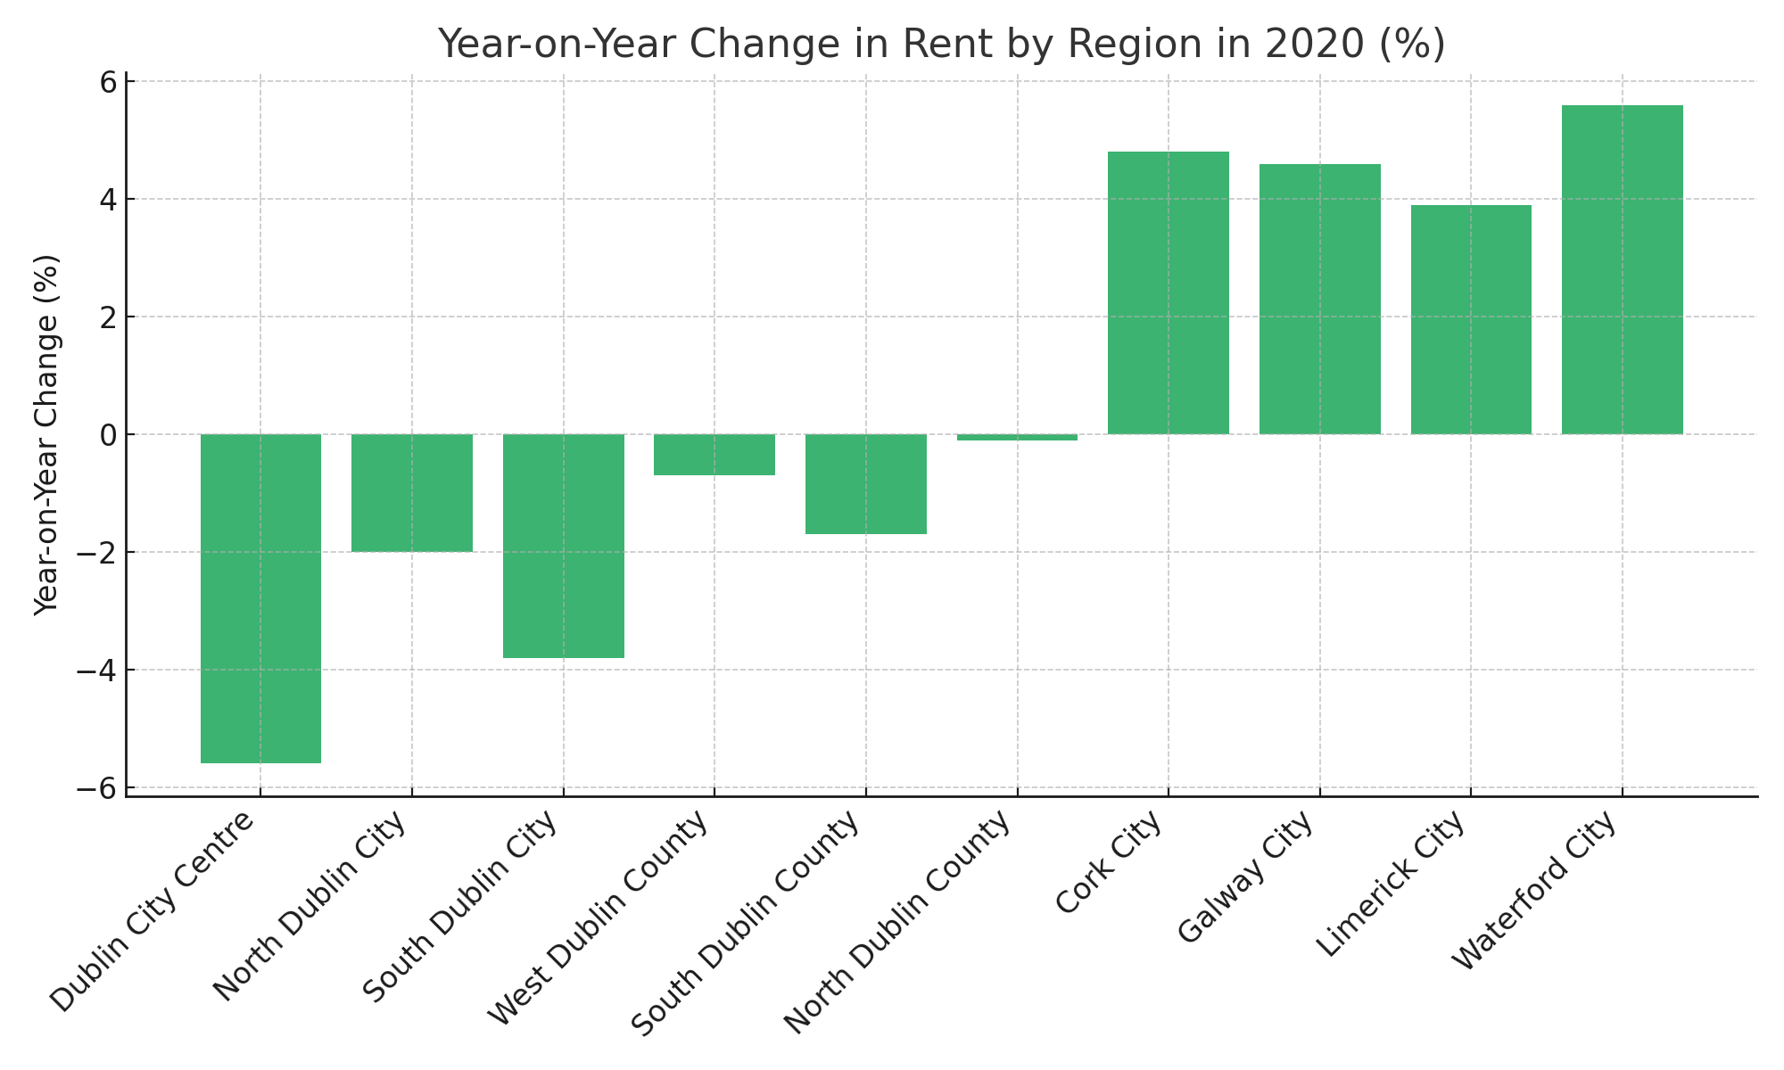

**Study of 2021**

In 2021, Dublin’s rental market began to recover from the declines experienced during the pandemic. Rents in Dublin increased by 2.5% year-on-year, reflecting a return to pre-COVID-19 dynamics of limited supply and strong demand. In Q3 2021, rents in Dublin were rising once again, with several areas seeing stronger growth.



**Economic Insights:**

* **Supply Crisis**: By November 2021, there were just 820 homes available for rent in Dublin, a 51% drop compared to the same time in 2020, marking the lowest stock of rentals since 2006.
* **Rent Growth Outside Dublin**: While Dublin rents were recovering, rural Ireland saw significantly higher rent inflation, influenced by changing housing preferences due to the pandemic.

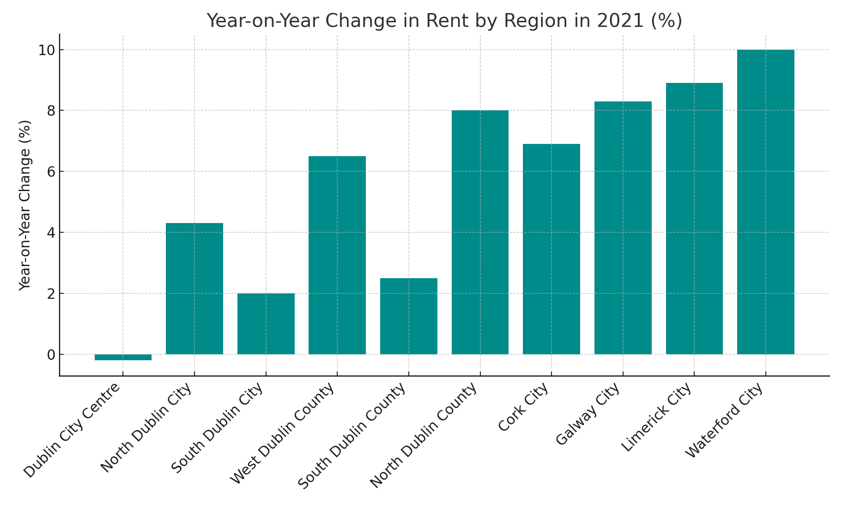

**Study of 2022**

In 2022, Dublin’s rental market saw significant increases in rents, with the market showing no signs of easing the persistent housing shortage. Nationally, market rents increased by 13.7% compared to 2021, making it the second largest year-on-year increase. In Dublin, rents grew by 13%, with a sharp increase in demand and a significant undersupply.



**Economic Insights:**

* **Critical Supply Shortage**: The number of available rental homes remained critically low, with fewer than 1,100 homes available to rent as of February 2023.
* **Surge in Urban Rents**: Dublin saw a surge in rents due to the high demand, while cities like Galway, Limerick, and Waterford experienced rent increases of nearly 20%.

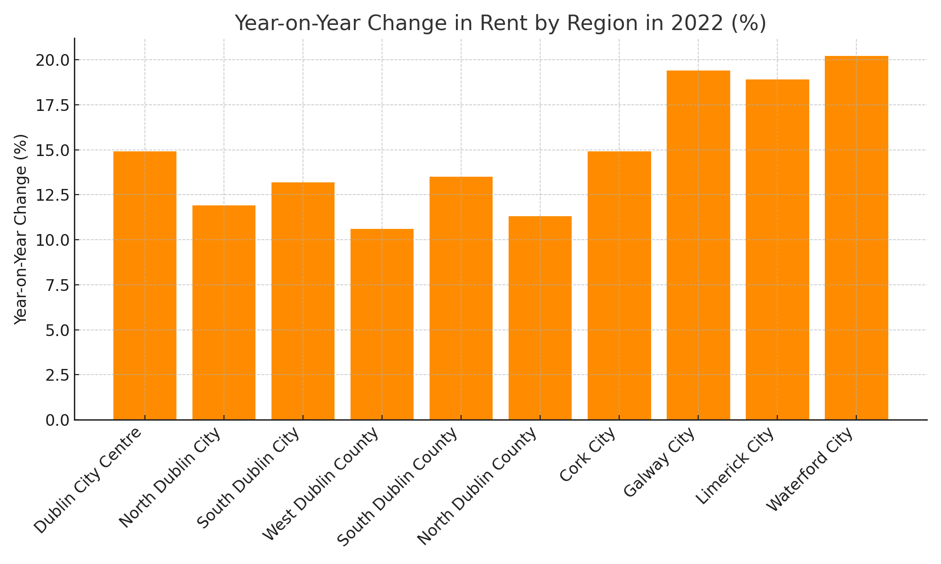

**Study of 2023**

Dublin’s rental market saw slower rental inflation in 2023, with rents rising by just 2.6% year-on-year. This is significantly lower than the 13% increase seen in 2022. The main driver behind this moderation was the increase in rental supply, particularly in Dublin, where the construction of new rental properties played a key role. Nationally, rental inflation was still present, but halved to 6.8% in 2023, compared to the 13.7% seen in 2022.



**Economic Insights:**

* **New Rental Supply**: Over 20,000 new apartments were constructed in Dublin between 2021 and 2023, which significantly slowed down rental inflation in the capital.
* **Rental Availability**: The supply of rental homes increased by 10%, with nearly 1,200 properties available for rent by February 2023. This improved availability is a positive development compared to recent years but is still below the pre-2019 averages.

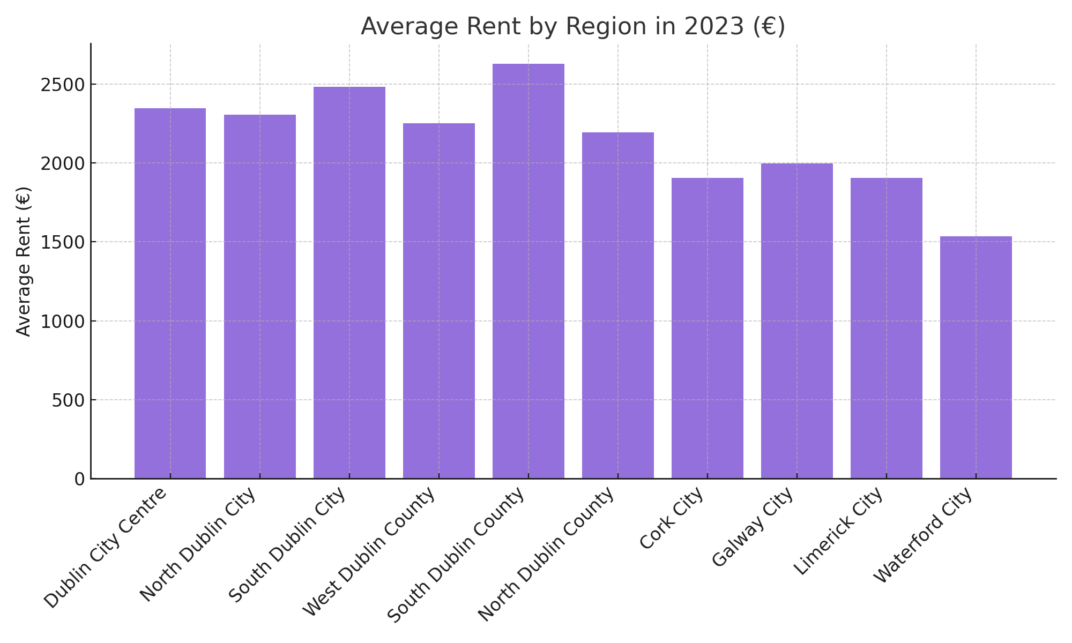

**Study of 2024**

In Q1 2024, Dublin’s rental market continued to stabilize, with rents increasing by 2.5% year-on-year. While this growth was moderate compared to previous years, pressure on rental supply remains, with rents continuing to rise across the country. Dublin’s rental inflation has slowed significantly compared to 2022, and the cooling inflation trend has spread to other parts of the country. Nationally, market rents increased by 4.9% year-on-year, down from a peak of 14% in mid-2022.



**Economic Insights:**

* **Stabilizing Inflation**: The slowdown in rental inflation, particularly in Dublin, indicates a stabilization of rental price growth. This contrasts with earlier years where double-digit increases were common.
* **Supply Challenges**: While new developments in Dublin helped to moderate the increase in rents, supply continues to be tight, especially outside Dublin where rental inflation remains higher.

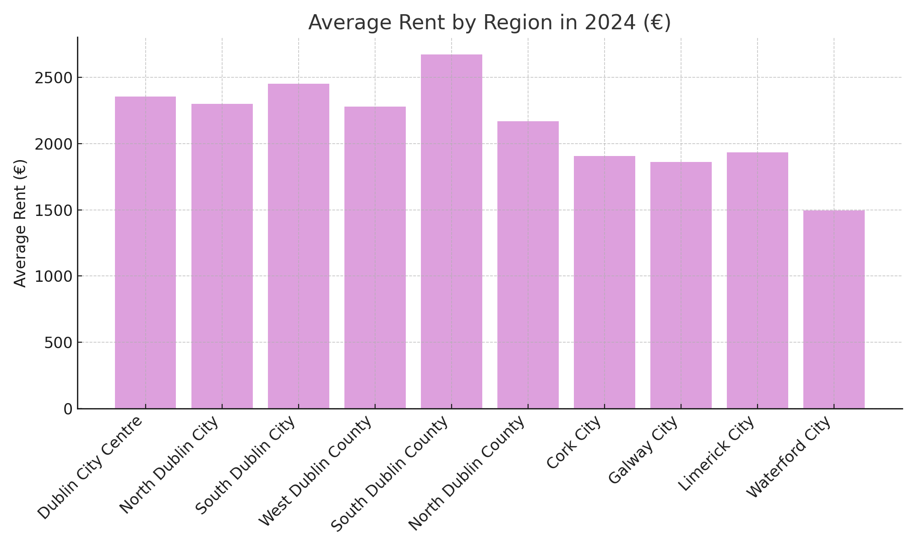

**Appendix 2**

GitHub Link: <https://github.com/CCT-Dublin/msc-data-analytics-capstone-thesis-july-2024-NOA-Data1>